

**Management & Science University,  
University Drive, Off Persiaran Olahraga,  
Section 13, 40100 Shah Alam,  
Selangor Darul Ehsan.**

**POSTGRAD THESIS MONITORING and CONTROLLING SYSTEM**

**(PGTMCS)**

**USER MANUAL for STUDENT**

Version 1.0

Document Reference: MSU/PGTMCS/UM/001

**DOCUMENT DETAILS**

|  |  |
| --- | --- |
| **Effective Date:** | 1st June 2015 |
| **Document Owner:** | Information Technology and Innovation Centre (ITIC) |

**REVISION HISTORY**

|  |  |  |  |
| --- | --- | --- | --- |
| **Date** | **Version** | **Description** | **Author** |
| 18th February 2015 | 0.1 | Document creation | Zuraimi, Amalina |
| 02nd March 2015 | 0.2 | Document review and update | Zuraimi |
| 19th May 2015 | 1.0 | Final | Zuraimi, Nizam |

**TABLE OF CONTENTS**

1 INTRODUCTION 7

1.1 Scope 7

1.2 System Requirement 7

1.2.1 URL 7

1.2.2 Internet Browser 7

1.2.3 User Access 8

1.3 Screen Design 8

2 USER LOGIN and LOGOUT 10

2.1 Login 10

2.2 Logout 10

3 CHANGE PASSWORD 11

3.1 Change Password 11

4 STUDENT PROGRAMME 12

4.1 Student Profile 12

4.2 Thesis 13

4.3 Supervisor/Co-Supervisor List 13

4.4 Subject Taken 14

4.5 Thesis History 14

5 SUBMIT NEW PROPOSAL 15

5.1 First Time 15

7 DISAPPROVED 25

7.1 Process Flow 25

7.2 Disapprove 25

8 CANCEL PROPOSAL 26

8.1 Process Flow 26

8.2 Request for Proposal Cancellation 27

9 Approval from Faculty 29

9.1 Approval from Faculty 29

10 EDIT PROPOSAL 30

10.1 Process Flow 30

10.2 Request Change 30

11 VIEW PROPOSAL 32

11.1 Process Flow 32

11.2 Approved 34

11.3 Approved with Changes 35

12 Monthly Progress Report 36

12.1 Thesis Chapter 36

12.1.1 Add Chapter 37

12.1.2 Update Chapter 38

12.1.3 Add Sub-Chapter 39

12.1.4 Update Sub-Chapter 40

12.2 Monthly Progress Report 41

12.2.1 New Progress Report 42

12.3 Progress Report History 51

13 Message 53

13.1 Inbox 53

13.1.1 View Message 54

13.2 New Message 55

13.2.1 Select Recipient 56

13.2.2 Upload Attachment 57

13.3 Sent 58

13.3.1 Read Message 59

14 Help 60

14.1 Online help - Student 60

14.2 User Manual 61

14.3 FAQ 62

Email Template - Student to Faculty 64

Thesis Proposal – Submission 64

Email Template - Student to Supervisor 65

Monthly Progress Report - Submission 65

**LIST OF FIGURES**

Figure 1: PGTMCS Screen Structure Design 10

Figure 2: Login Page 11

Figure 3: Logout Page 12

Figure 4: Change Password Page 12

Figure 5: Student Programme Tab 13

Figure 6: List of Supervisor / Co-Supervisor 14

Figure 7: Subject Taken 15

Figure 8: Student Programme – Thesis History 16

Figure 9: First Time Proposal Preparation 17

Figure 10: New Proposal Page 18

Figure 11: New Proposal Page – Next Section 19

Figure 12: New Proposal Page – Next Section 19

Figure 13: Thesis Proposal Area Searching Page 20

Figure 14: Thesis Proposal Area – Thesis Proposal Area Category Selection Page 20

Figure 15: Thesis Proposal Area – Thesis Proposal Area Description 20

Figure 16: Discussion Detail 21

Figure 17: Search Staff Page - Select Lecturer 22

Figure 18: Discussion Detail 22

Figure 19: Attachment List 23

Figure 20: Upload Attachment 23

Figure 21: New Proposal Page – Next Section 24

Figure 22: New Proposal Page – After submission 25

Figure 23: Proposal Disapproved by Faculty 27

Figure 24: Proposal Cancellation 28

Figure 25: Request for Cancellation 29

Figure 26: Request for Cancellation 29

Figure 27: Request for Cancellation 30

Figure 28: Request Changes – Edit Proposal 31

Figure 29: View Proposal – Approved by Senate 35

Figure 30: View Proposal – Approved with Changes by Senate 36

Figure 31:Thesis Chapter 37

Figure 32: Add Chapter 38

Figure 33:Chapter No 38

Figure 34:Add Chapter 39

Figure 35: Update Chapter 39

Figure 36: Add Sub-Chapter 40

Figure 37: Chapter No 40

Figure 38: Sub-Chapter No 40

Figure 39: Add Sub-Chapter 41

Figure 40: Update Chapter 41

Figure 41: Monthly Progress Report 42

Figure 42: New Report 43

Figure 43: 44

Figure 44: 44

Figure 45: Add Discussion Date 45

Figure 46: Discussion Date 45

Figure 47: Meeting Date 46

Figure 48: Meeting Start & End Time 46

Figure 49: Edit/Delete Discussion Date 46

Figure 50: Add Attachment 47

Figure 51: Add Attachment 47

Figure 52: Browse 48

Figure 53: Choose Attachment 48

Figure 54: Finish Upload 48

Figure 55: List of attachment 49

Figure 56: Finish uploading 49

Figure 57: Finish Submitting 49

Figure 58: Edit Report 50

Figure 59: Edit Report 51

Figure 60: Edit Report 51

Figure 61: List of Progress Report History 52

Figure 62: Thesis Detail 53

Figure 63: Progress Report History Detail 53

Figure 64: Message 54

Figure 65: Read Message 55

Figure 66: New Message 56

Figure 67: Select Recipient 57

Figure 68: Select Recipient- Next Section 57

Figure 69: Upload Attachment 58

Figure 70: Upload Attachment- Next Section 58

Figure 71: Sent 59

Figure 72: Read Message 60

Figure 73: Online Help 61

Figure 74: User Manual 62

Figure 75: FAQ 63

# INTRODUCTION

Postgraduate Thesis Monitoring and Controlling System (PGTMCS) version 1.0.0 is a system for the Student, Supervisor, Faculty and Senate to monitor the status of thesis proposal from its initial stage toward to the end. It is not only use by the respective personnel to control and manage the quality of the thesis to meet the university standard but it also can be used to keep track all the communication between the student and university. If required the history can be retrieved to view the completed work or its progress.

The system contains the main modules which are Thesis Proposal Submission and Approval, Monthly Progress Report Review, Thesis Proposal Defense, Thesis Work Completion, Thesis Evaluation/Viva and Senate Endorsement.

The Thesis Proposal Submission and Approval module will be the first release made available for use by the student and staffs. The rest of the module will be released by stages.

## Scope

As the scope of this manual will cover the first release of the module, it will guide the student how to use the system and what would they need to do in the case of proposal get approved, changes needed or disapproved by the faculty or senate.

The student also will know the status of the proposal for each of the proposal stage either in draft mode, pending decision or it has been confirmed / approved by the faculty / senate.

The remaining guideline for other modules will be updated in the next user manual release.

## System Requirement

### URL

The system is available over the internet via the URL <http://postgrad.msu.edu.my> and accessible only by the registered and authorized postgraduate student and respective MSU’s staff.

### Internet Browser

It is recommended to run the system on the following internet browser

* Mozilla Firefox version 35 and above
* Microsoft Internet Explorer version 8 and above

### User Access

The postgraduate student who has been successfully registered in Campus Management System (CMS) will be automatically become postgraduate user or otherwise the student needs to check with the CMS admin on his/her status. By default Student Matrix Number will be the user id to access the PGTMCS system.

The MSU’s staff that has been identified as reviewer, supervisor or co-supervisor can access the PGTMCS system once the PGTMCS admin registered him/her into the system. By default Employee ID will be the user id to access the PGTMCS system.

## Screen Design

The PGTMCS system screen has been design into the 5 sections namely section A, B, C, D and E.

Section A to cater the PGTMCS **Header** in which it contains the name of the system, the user name and Logout button

Section B to cater the PGTMCS **Top Panel** in which it contains the list of functions for the system.

Section C to cater the PGTMCS **Left Panel** in which it contains the list of sub-functions resulting from the selection in Section B.

Section D to cater the PGTMCS **Working Area** in which it shows the page for user respond resulting from the selection in Section C.

Section E to cater the PGTMCS **Footer** in which it contains the university name and its copyright.

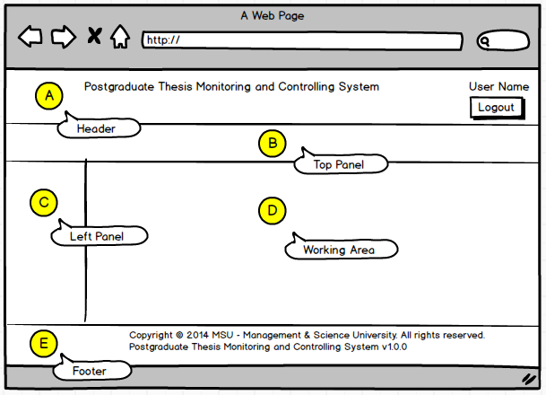

Figure 1: PGTMCS Screen Structure Design

# USER LOGIN and LOGOUT

## Login

This is the first page sight by the student to enter the PGTMC system.

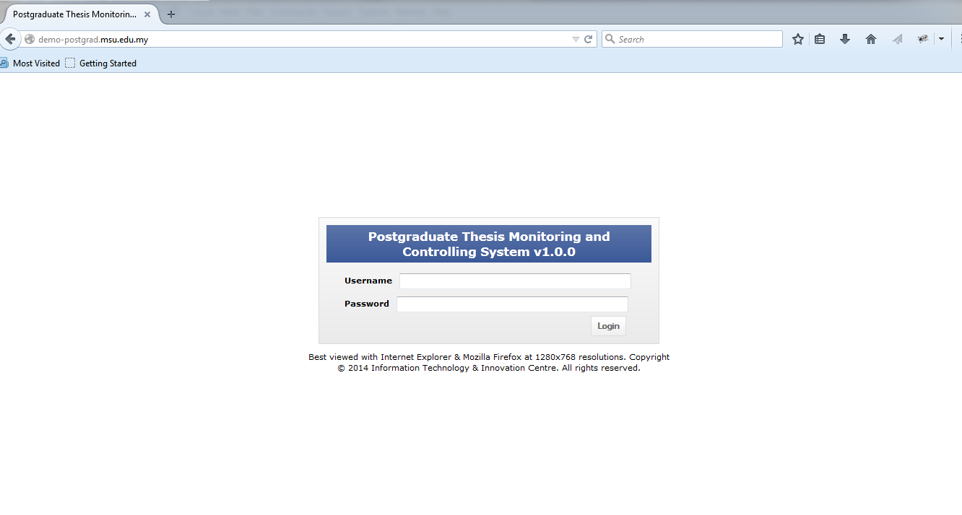

Student need to **login** Postgraduate Thesis System to create a New Proposal.

Figure 2: Login Page

**Steps:-**

1. Open any Internet Browser of your choice either Mozilla Firefox or Microsoft Internet Explorer
2. Enter the URL to access the system as follows <http://postgrad.msu.edu.my/>
3. Login page will be displayed in which the valid user credential needs to be provided i.e. **Username** and **Password**.

## Logout

Once the necessary or required activities has been done or completed, the student can quit from the system by clicking on the **Logout** button.

If the system is keep idle for about 1 minute, the system will logged out the user automatically.

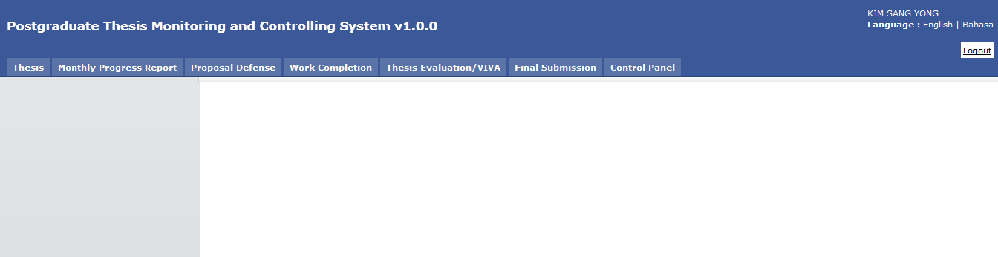

Button **Logout**.

Figure 3: Logout Page

**Steps:-**

1. Find the **Logout** button located on the right top corner of the system **Header** section.
2. Click on it and you will be logout from the system successfully.

# CHANGE PASSWORD

## Change Password

For the security reason, the user is strongly recommended to change the password at first successful login to the system.

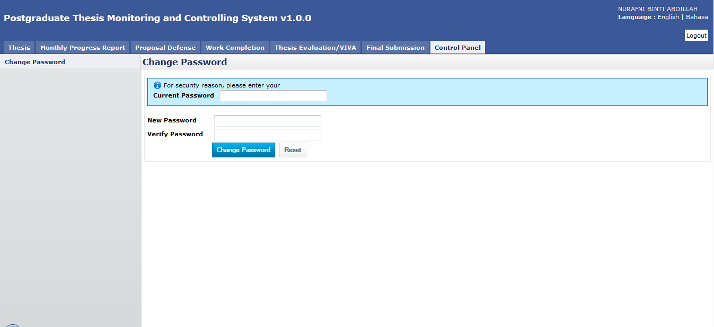

Figure 4: Change Password Page

**Steps:-**

1. Click on the **Control Panel** tab from the system **Top** panel section.
2. The **Change Password** menu will be displayed and click on it.
3. As to ensure the right user able to change the password, the system will ask **Current Password** used before able to change it to the new password.
4. Once the **Current Password** has been provided, the **New Password** and **Verify Password** can be provided afterward.
5. Click **Change Password** button to ensure the new password can be saved into the system successfully.
6. If the **Current Password** is incorrect, the system will prompt an error message and the user needs to redo the same steps above.
7. User can use **Reset** button if wanted to clear the entry on each fields.

# STUDENT PROGRAMME

Student Programme will contain all information that related to students, which are Student Profile, Thesis, Supervisor/Co-supervisor lists, Subject Taken and Thesis History.

## Student Profile

Student Profile tab contains the basic student and thesis information including its thesis progress status.

Menu Tab for Student Profile, Thesis, Supervisor/Co-supervisor, Subject Taken, and Thesis History

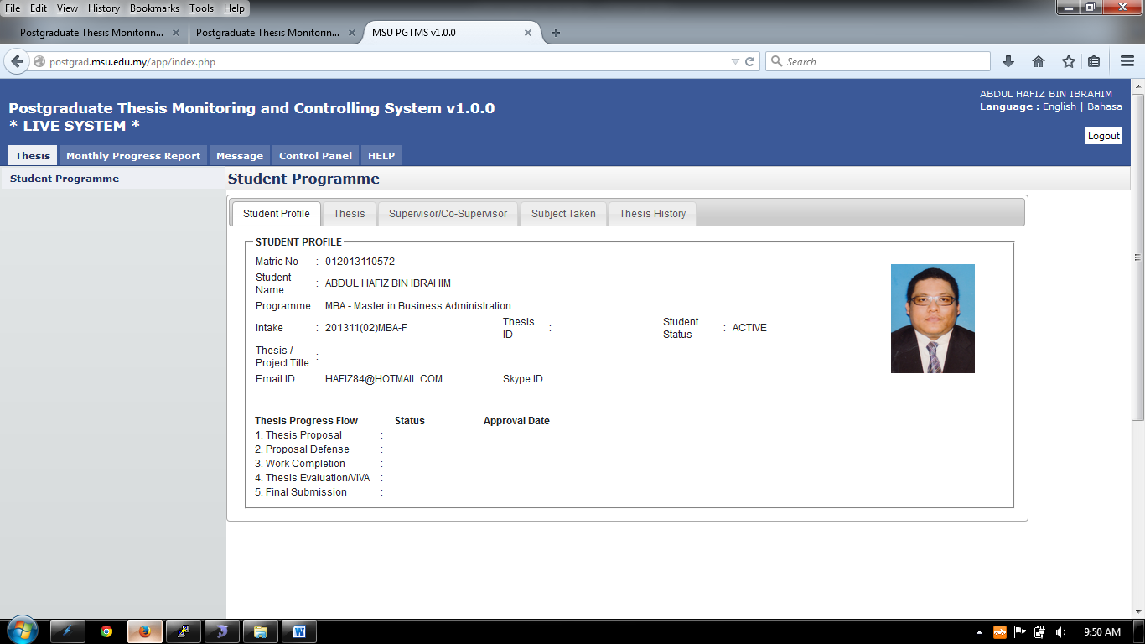

Figure 5: Student Programme Tab

**Steps:-**

1. Click on the **Thesis** tab on the system **Top** panel section.
2. The **Student Programme** menu will be displayed on the system **Left** panel and click on it.
3. The other 5 tabs will be displayed on the **Working Area** section in which each tab will contain the information as mentioned previously.

## Thesis

**Thesis** tab is the page where the student can submit, amend and view the proposal. Please refer next sections for details steps.

Each thesis proposal will be assigned with the Thesis ID which follows the naming convention below:

*The Date when the proposal is sent submitted*

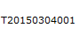

*Running number*

*It stands for Thesis*

## Supervisor/Co-Supervisor List

Supervisor or Co-Supervisor is the academic staff who has been assigned by Faculty to supervise the student in delivering the thesis and approved by the Senate.

There are conditions for the student to see the list of his/her supervisors. The conditions are:-

1. Supervisor/Co-Supervisor has been assigned by Faculty and approved by the Senate
2. Supervisor/Co-Supervisor has accepted the appointment to supervise the student.

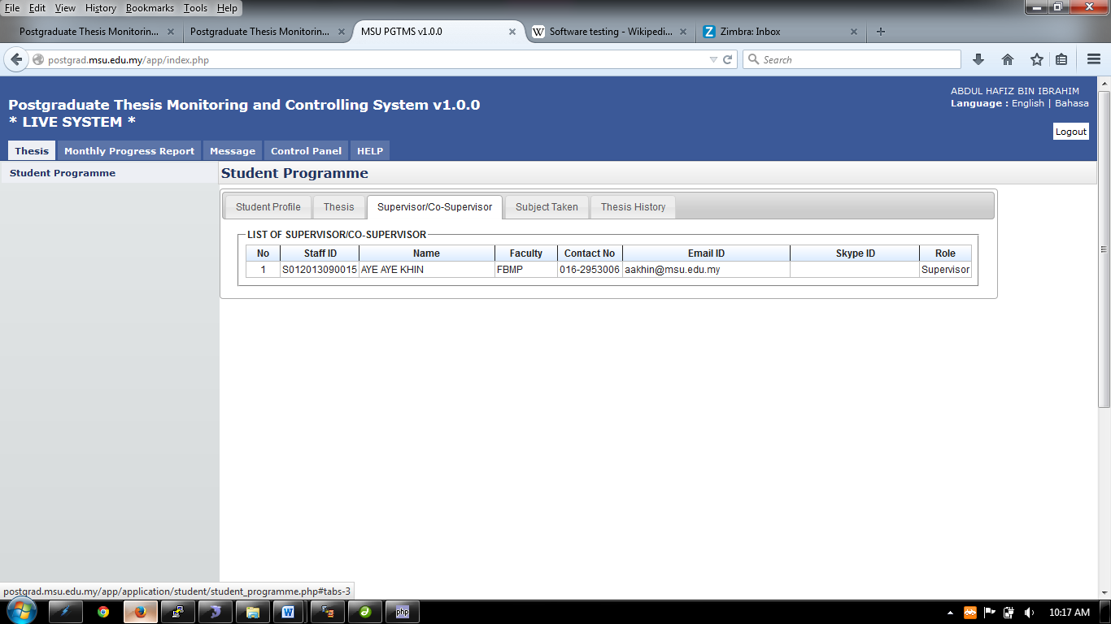

Figure 6: List of Supervisor / Co-Supervisor

**Steps:-**

1. Click on the **Thesis** tab on the **Top** panel
2. Click on the **Student Programme** menu on the **Left** panel
3. Click on the **Supervisor/Co-Supervisor** tab on the **Working Area**
4. System will display the list of the supervisor/co-supervisor which has been assigned and approved by Senate.

## Subject Taken

Subject Taken tab will list the entire subject registered by the students for all semester during his study.

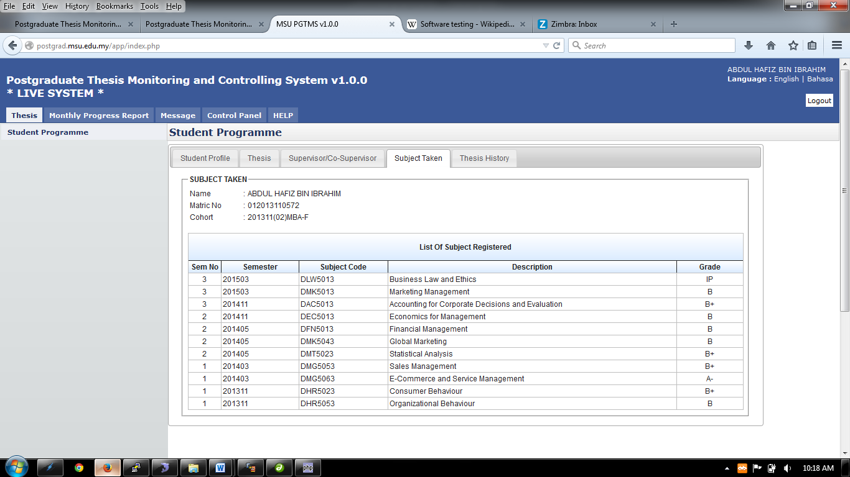

Figure 7: Subject Taken

**Steps:-**

1. Click on the **Thesis** tab on the **Top** panel
2. Click on the **Student Programme** menu on the **Left** panel
3. Click on the **Subject Taken** tab on the **Working Area**
4. System will display the list of the subject taken by the student from his/her first semester till current.

## Thesis History

Thesis History tab contains the proposal progress history starting from its submission by the student tills its approval by the Senate.

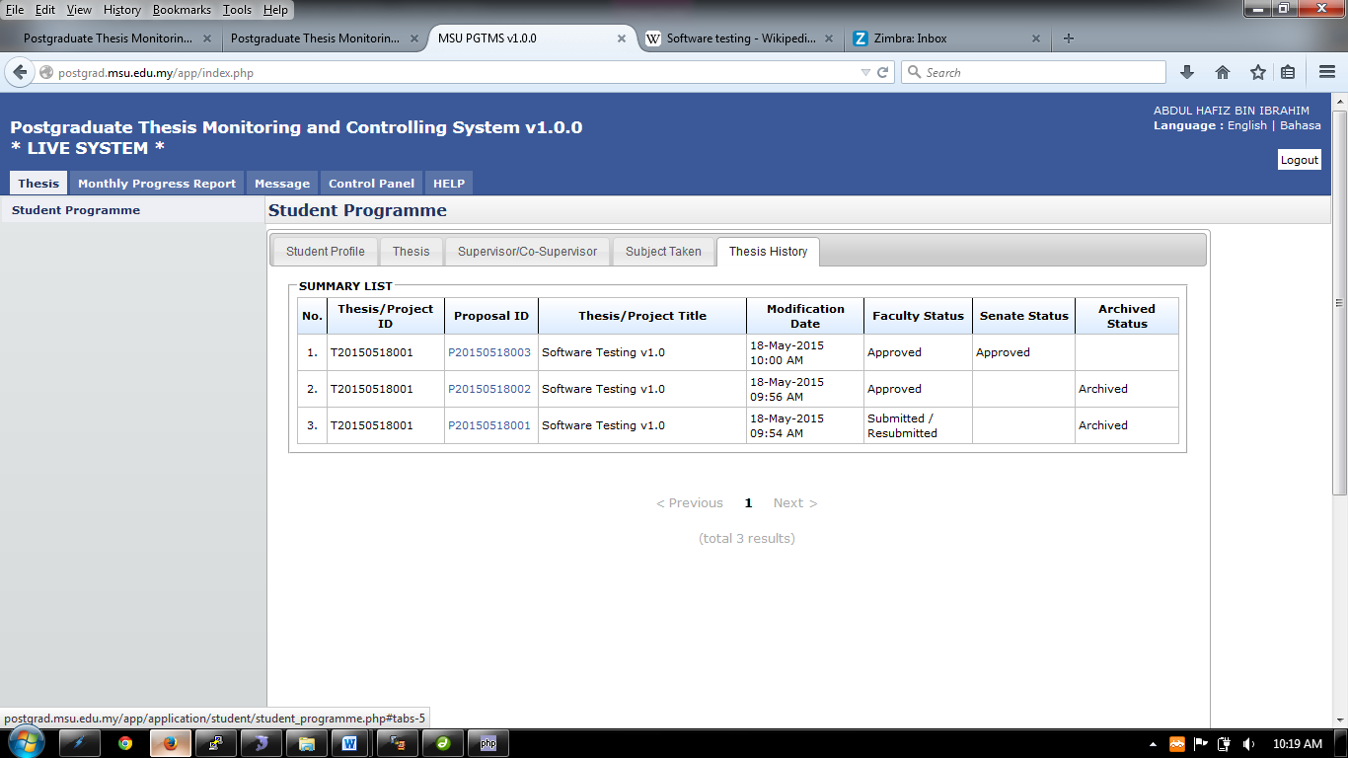

Figure 8: Student Programme – Thesis History

**Steps:-**

1. Click on the **Thesis** tab on the **Top** panel
2. Click on the **Student Programme** menu on the **Left** panel
3. Click on the **Thesis History** tab on the **Working Area**
4. System will display the list of the thesis history starting from its submission till its approval.

# SUBMIT NEW PROPOSAL

## First Time

When first time login to the system, the user will see the message from the system as shown in the figure below asking for proposal preparation and submission to the Faculty.

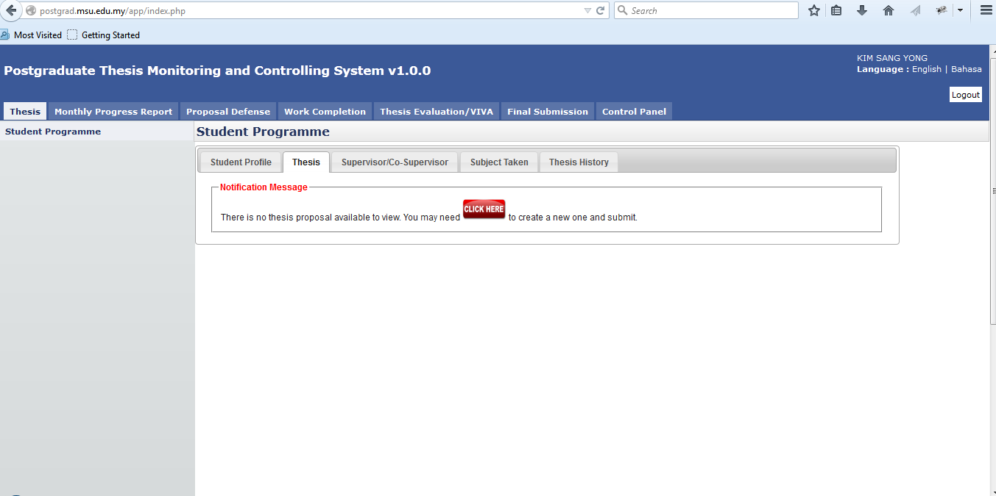

Figure 9: First Time Proposal Preparation

**Pre-condition**

1. No history of submitting thesis proposal

**Post-condition**

1. Submit proposal
2. Proposal cancellation can be made
3. Wait for faculty and senate to respond

**Steps:-**

1. Click on the **Thesis Tab** on the Top Panel.
2. System will show the message to prepare and submit the proposal.
3. Click on the **Click Here** button to create the proposal.

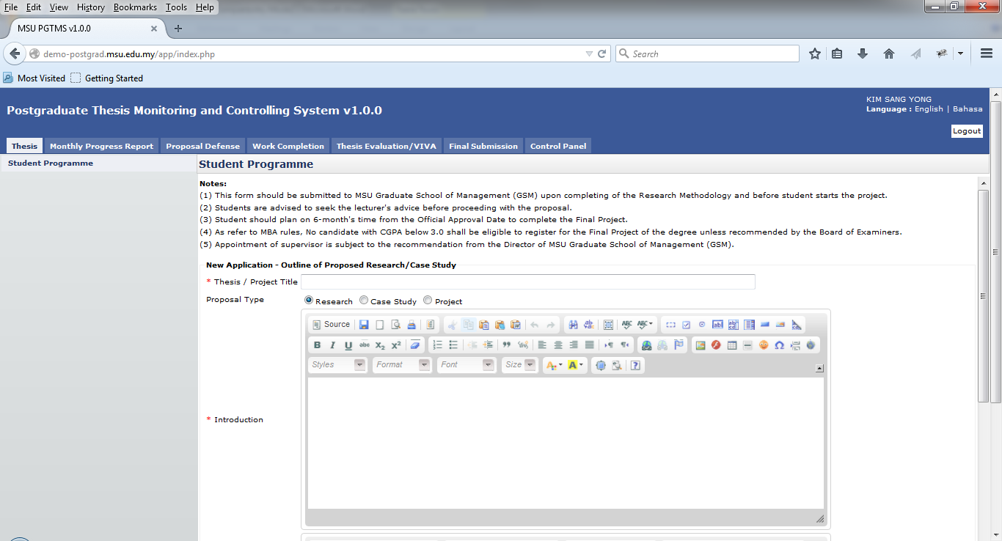

Figure 10: New Proposal Page

1. Enter the **Thesis / Project Title**
2. Select **Proposal Type**
3. Enter the necessary description into the **Introduction**

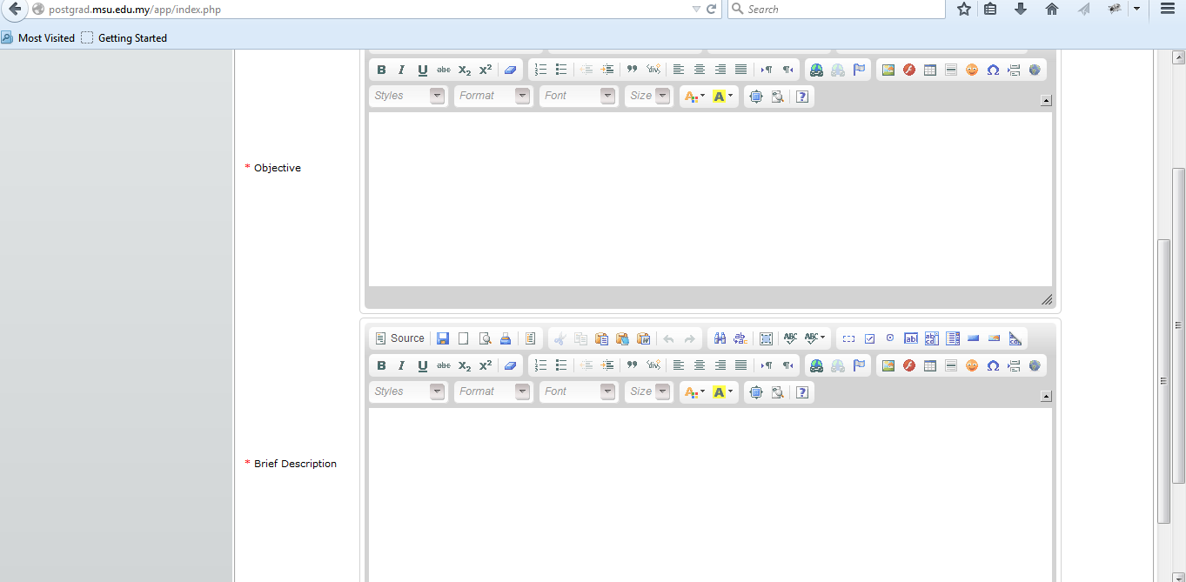

Figure 11: New Proposal Page – Next Section

1. Enter the necessary description into the **Objective**
2. Enter the necessary description into the **Brief Description**

Click Select link to choose Thesis Proposal Area.

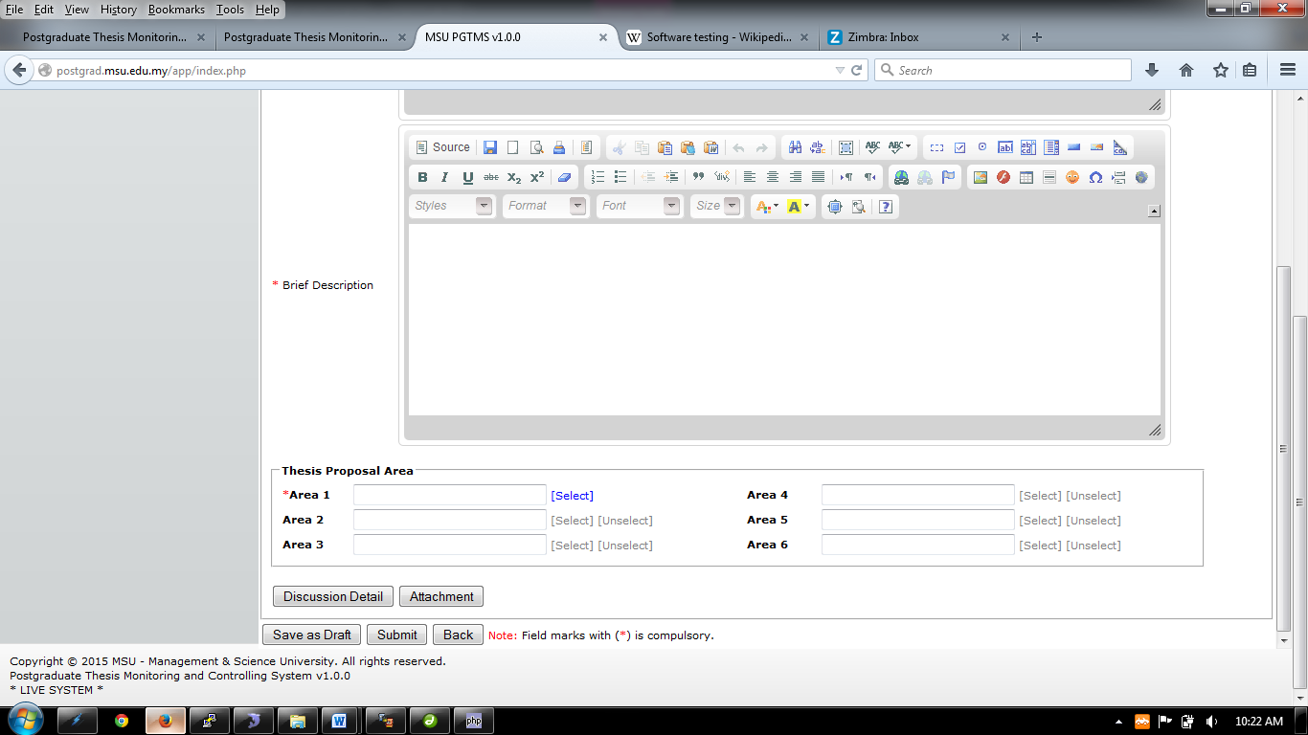

Figure 12: New Proposal Page – Next Section

1. Minimum 1 **Thesis Area** need to be selected to associate with the proposal. That will also enable the Faculty to assign the right and suitable Supervisor / Co-supervisor to consult with the student.

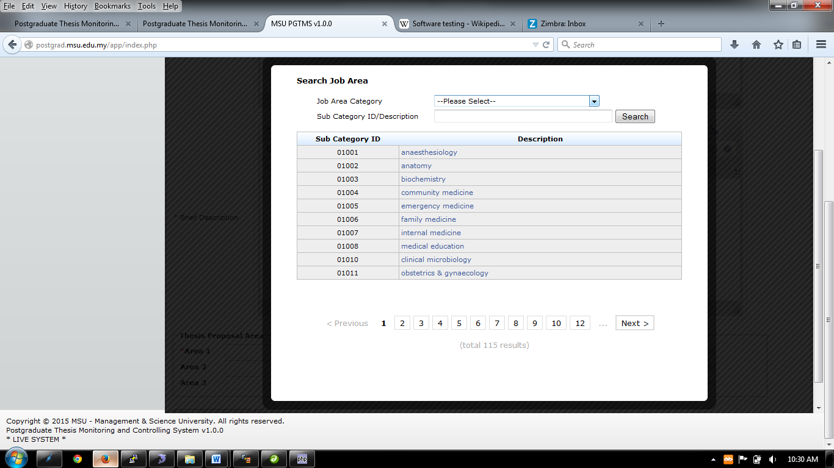

Figure 13: Thesis Proposal Area Searching Page

1. On Thesis Area page, by default it will list all the result if the searching is donewithout provide the required searching criteria i.e. Thesis Area, Sub-category ID or Sub-Category Description.

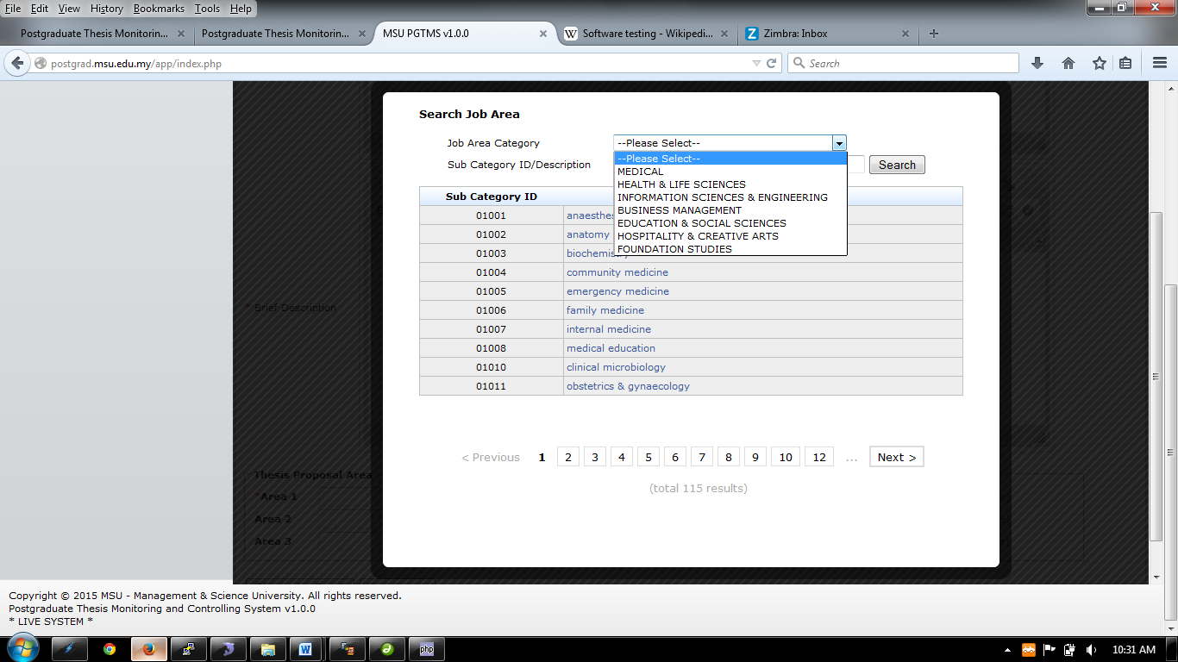

Figure 14: Thesis Proposal Area – Thesis Proposal Area Category Selection Page

1. The Job Area Category lists all the category for Thesis Proposal.

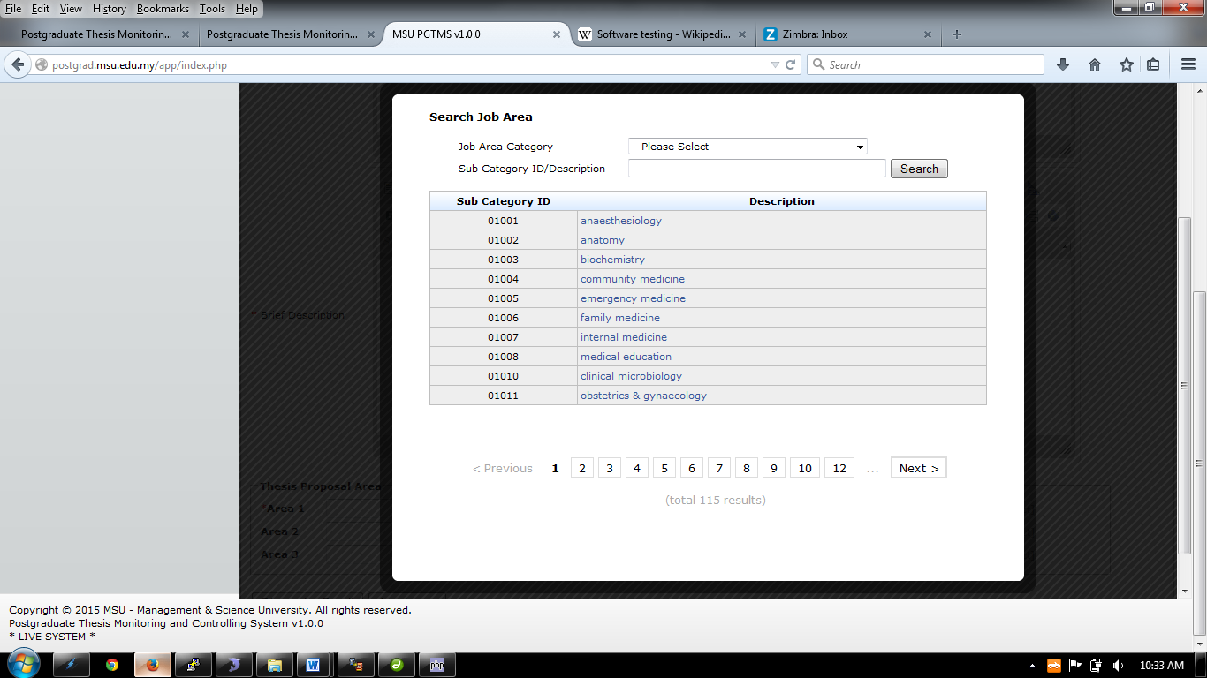

Figure 15: Thesis Proposal Area – Thesis Proposal Area Description

1. Alternatively, the description also can be input by the user to search a specific thesis area category.



Click Discussion Detail button to insert discussion detail.

Click Attachment button to insert attachment.

Figure 12: New Proposal Page – Next Section

* Please click **Save as Draft** first before proceeds. If not, all the detail which has been entered will be discarded.

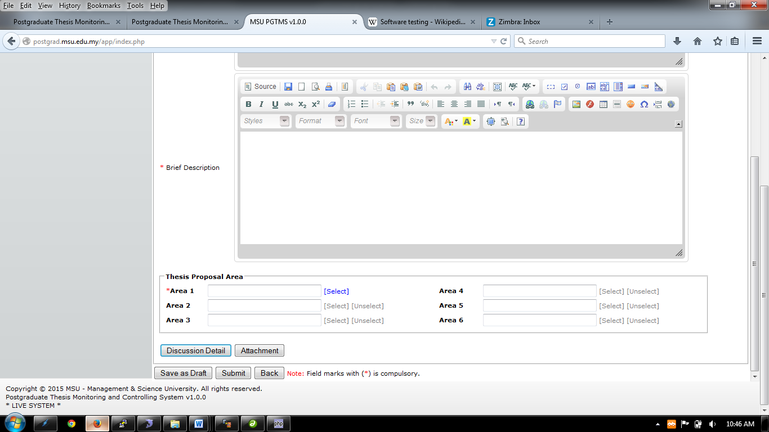

Figure 13: New Proposal Page – Next Section

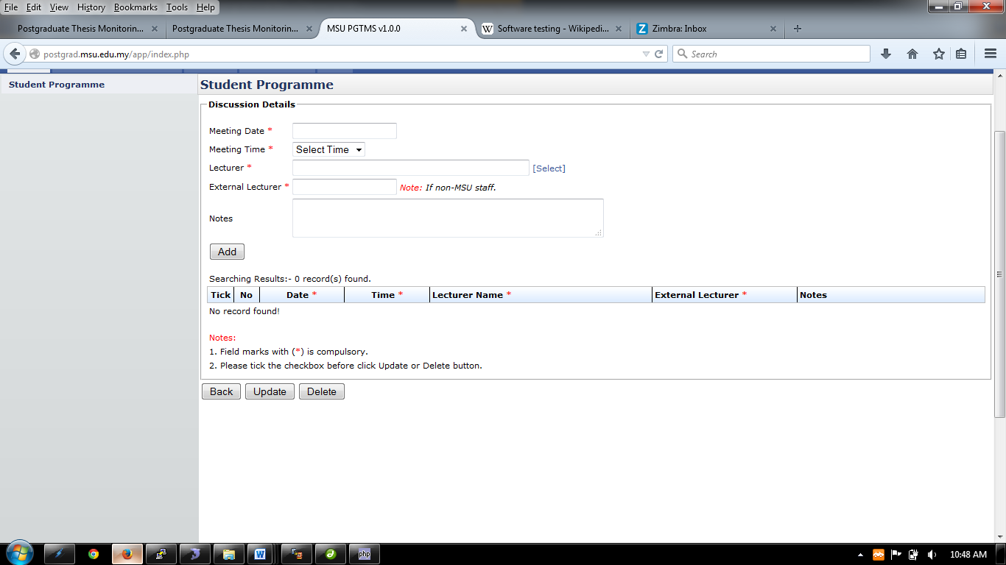 Figure 16: Discussion Detail

Click Select here to search and select the lecturer

1. Enter the discussion detail such as Meeting Date, Meeting Time, Lecturer or External Lecturer and Notes. All the field mark with * is compulsory.
2. To select or choose lecturer involve, click **Select** link.
3. Then click **Add** Button to proceed.

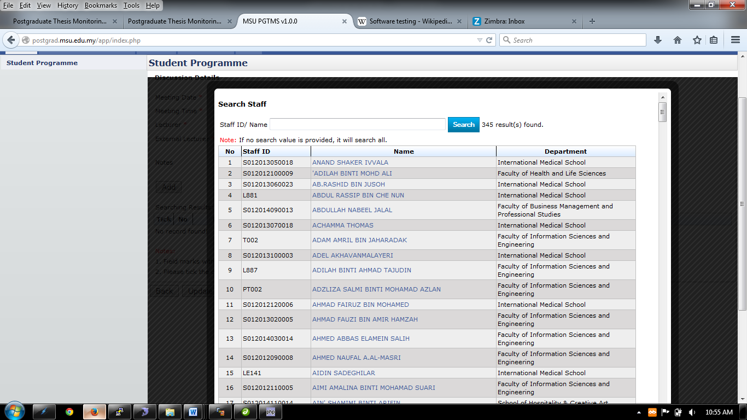

Figure 17: Search Staff Page - Select Lecturer

1. On the **Search Staff** page, if the searching is done without enter the searching criteria, it will show all the lecturers.
2. If the Staff ID or Name is provided, then the searching for that particular lecturer will be done.
3. Based on the search result list, click on the selected lecturer to pick his/her name so that it will be populated into the Lecturer field list.

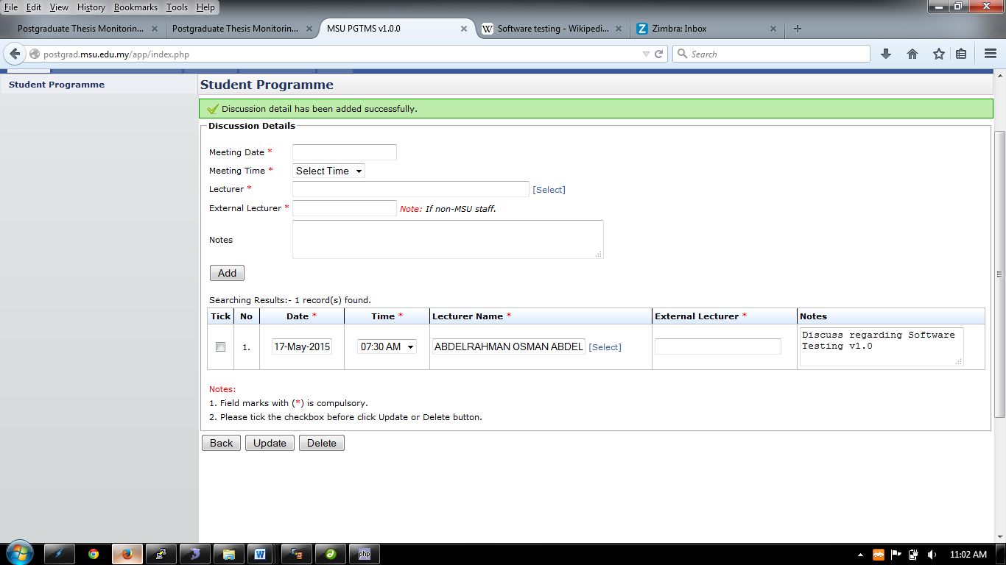

Figure 18: Discussion Detail

1. Once all the required information have been provided, then click **Add** button to add it into the discussion list.
2. To change or update the record, user can do it to the particular record.
3. Then **tick** the checkbox and click **Update** Button.
4. To delete the detail, **tick** the checkbox, and click **Delete** button to delete detail.
5. To go back to the previous page, click **Back** Button

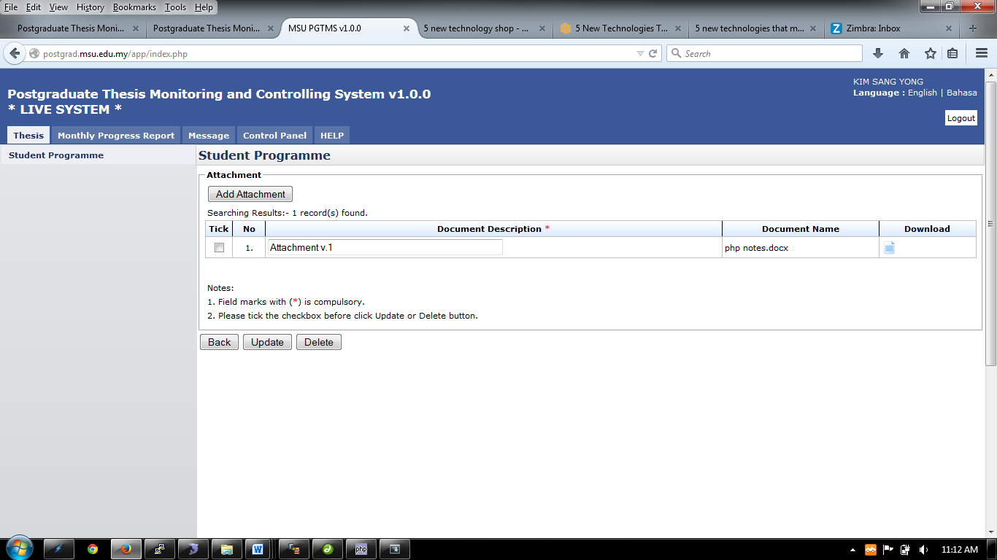 Figure 19: Attachment List

1. To insert or add attachment, click **Add** Attachment button and windows popup will appear as figure 12.2.1.

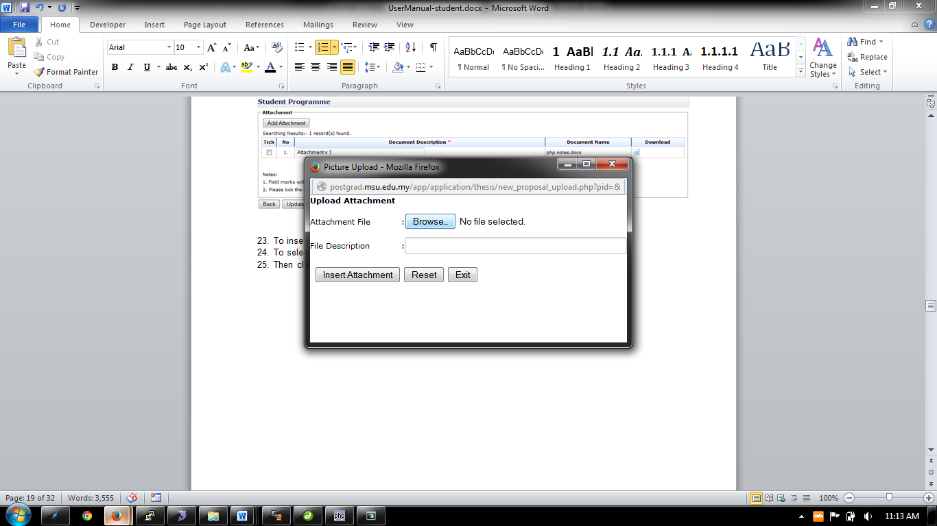

Figure 20: Upload Attachment

1. Choose or **Browse** selected file that need to upload. File Description is not compulsory, so it can proceed by click **Insert Attachment** button. Then it will display like Figure 12.2.
2. To Update Document Description, click on the field and change the description. Then tick the checkbox on the left side and click **Update** button to update.
3. To delete attachment, tick the checkbox and click the **Delete** button to delete.
4. To go back to previous page, click **Back** button

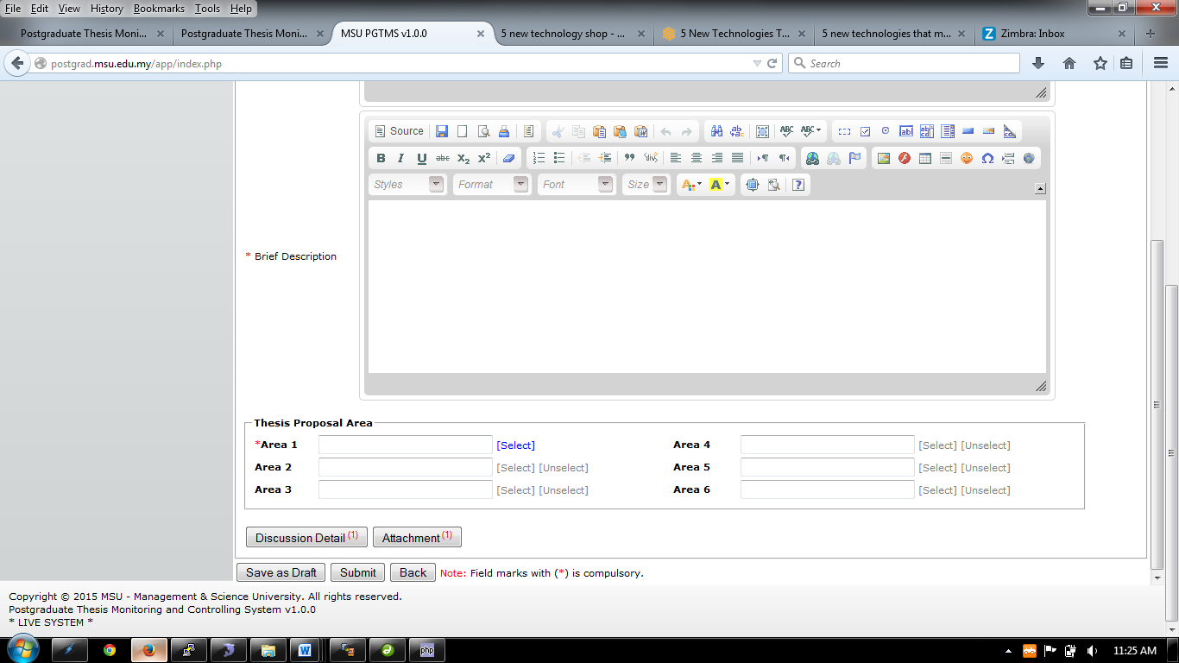

Figure 13: New Proposal Page – Next Section

1. After the discussion detail and attachment has been insert, the number of discussion detail that being insert and the number of attachment uploaded will be shown on the button.

**Save as Draft** – Student can save the draft before they submit the application

**Submit** – Once student finish all the input draft and submit to Faculty for approval.



**Back** – Student can click button Back if they Save as Draft.

Figure 21: New Proposal Page – Next Section

1. After all the necessary information has been provided, the student can save it temporarily via **Save as Draft** button in case there is a need to be reviewed and updated later. Once finalize, it can be submitted to the Faculty and Senate for approval and becomes a thesis.
2. Click **Back** button if to return back to **Student Programme** page.
3. If the proposal has been finalized and ready to submit for approval, the student can send it to Faculty via **Submit** button. Any changes cannot be done until the proposal is returned back by Faculty due to any changes needed.
4. When **Submit** buttonis being clicked, the email notification will be sent to the faculty by the system. (Refer Appendix)

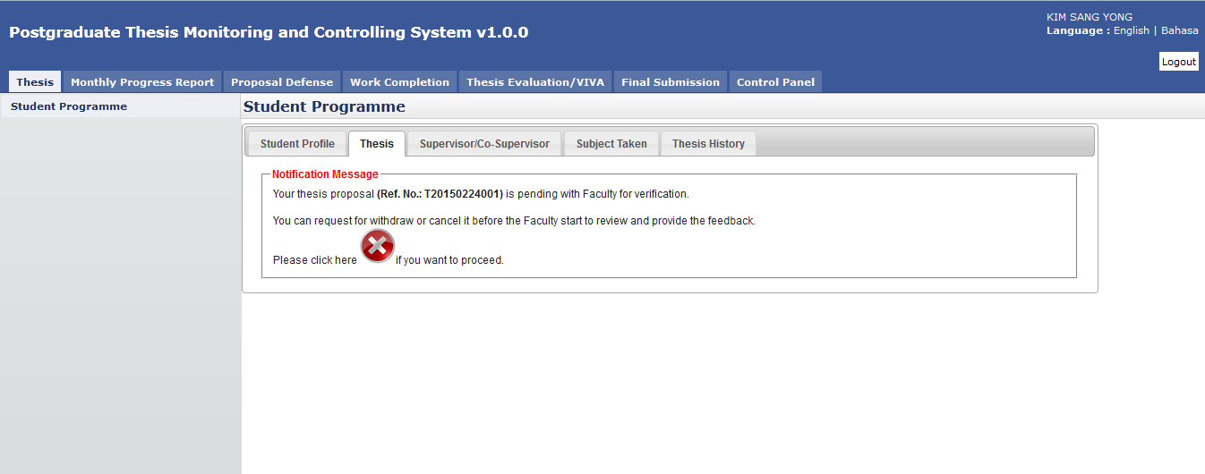

Figure 22: New Proposal Page – After submission

1. After submit, system will notify student that their proposal has been successfully submitted to the Faculty for approval.
2. If the student has changed his/her mind to withdraw or cancel the newly submitted proposal, he/she can do that via cancel button  as shown above. Please refer next section on how to cancel the proposal.

# DISAPPROVED

## Process Flow

1. **First Scenario**

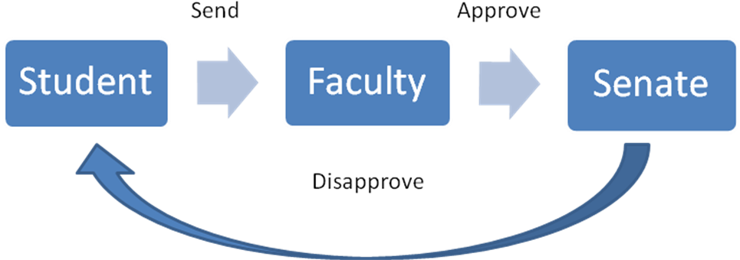

The first scenario, student will send the thesis proposal to get approval from Faculty but the thesis proposal was **Disapprove** by Senate because of the certain reason and student will notify through postgraduate system.

1. **Second Scenario**

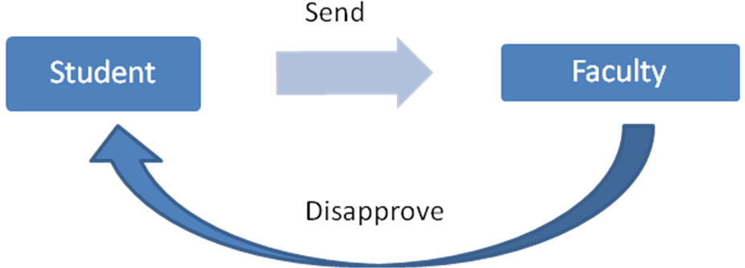

The second scenario, Faculty was **Disapprove** the thesis proposal before the thesis proposal sent to Senate for endorsement.

## Disapprove

If there is a case where the thesis proposal does not meet the expectation of the Faculty or the content does not fit the title, the proposal may be rejected or disapproved by the Faculty.

For this scenario, the system will notify the student on the proposal status.

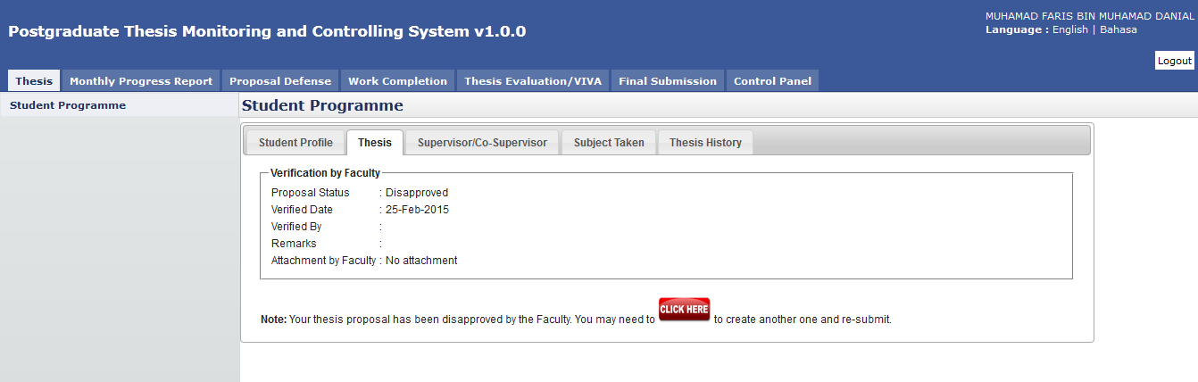

Disapproval notification by Faculty.

Figure 23: Proposal Disapproved by Faculty

**Steps:-**

1. After the proposal has been submitted to the Faculty, the Faculty will review it and determine its status. In case the proposal gets rejected due to some reason, the student can check it via **Thesis** tab.
2. Click **Thesis** tab on **Top** panel
3. Click on the **Student Programme** on the **Left** panel
4. Click on the **Thesis** Tab on the **Working Area** section.
5. The system will show the proposal status and the student can read the **Remarks** and download the **Attachment** from Faculty (if any).
6. For this case, the student can amend the proposal according to the advice given by the Faculty.
7. Click on the **Click Here** button to proceed and resubmit.

# CANCEL PROPOSAL

## Process Flow

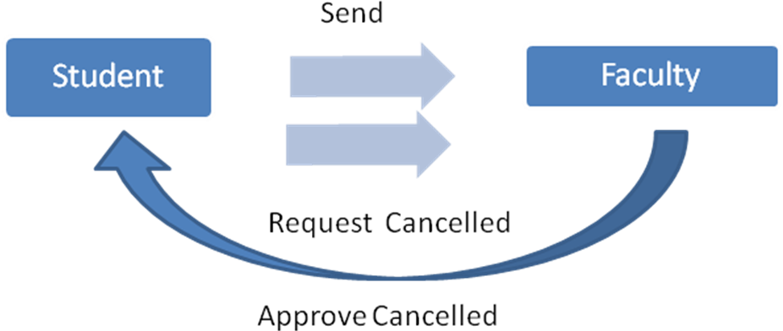

This level, student request cancellation from Faculty after sent the thesis proposal. Faculty will response through the system and notify student the cancellation.

## Request for Proposal Cancellation

Student is allowed to cancel his/her newly submitted proposal in case he/she realizes some amendment need to be done. For this case the student can request for proposal cancellation as shown below.

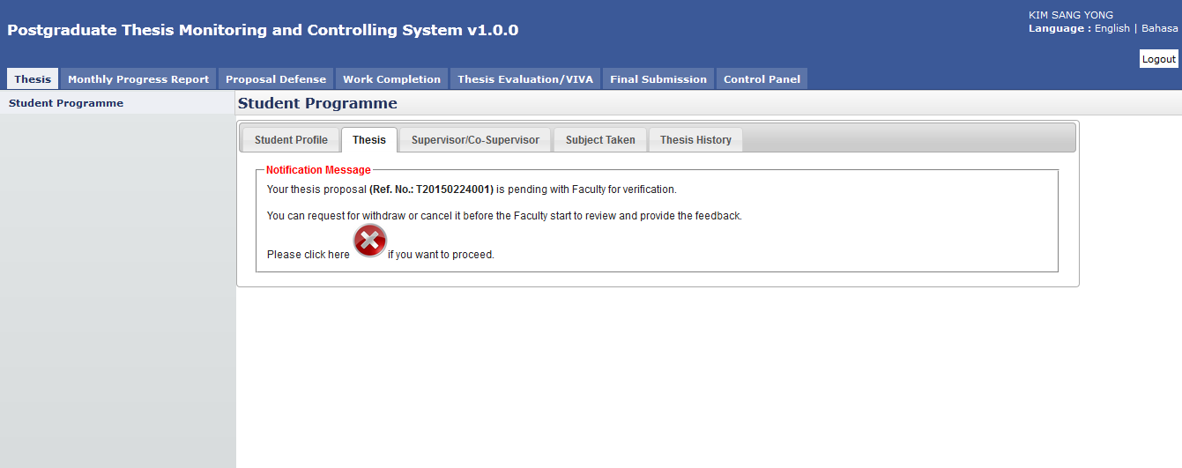

For a Request Cancellation, students need to click this button to continue.

Figure 24: Proposal Cancellation

**Pre-condition**

1. Already submit proposal
2. Faculty status still pending

**Post-condition**

1. Create new proposal
2. Edit proposal

**Steps:-**

1. Click on the **Thesis** tab on the **Top** panel
2. Click on the **Student Programme** menu on the **Left** panel
3. Click on the Thesis tab on **the Working Area**
4. System will display the notification message to the student indicate that the proposal has been successfully submitted to the Faculty.
5. If the student decided to cancel the proposal, he/she can click on the  cancel button. Please note the cancellation only can be done if the Faculty is not yet provide the feedback.

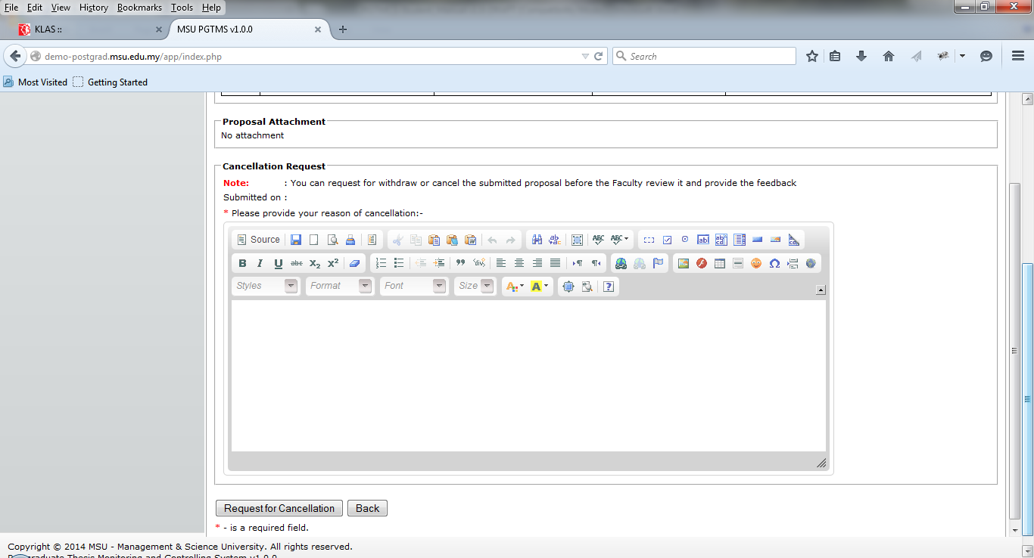

Click button to proceed

Figure 25: Request for Cancellation

1. The student needs to provide the justification of the cancellation and once confirm click the **Request for Cancellation** button.
2. Otherwise the student can click **Back** button and wait feedback from the Faculty and Senate.

System will notify student after click button Request Cancellation.

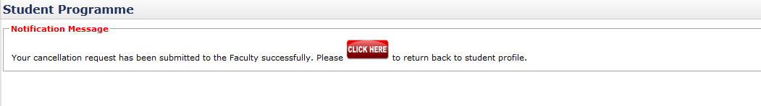

Figure 26: Request for Cancellation

1. The above message will be displayed after the student submits the cancellation request to the Faculty.

# Approval from Faculty

## Approval from Faculty

Once the Faculty approved the proposal cancellation request, the student can see the notification message from the system as shown below.

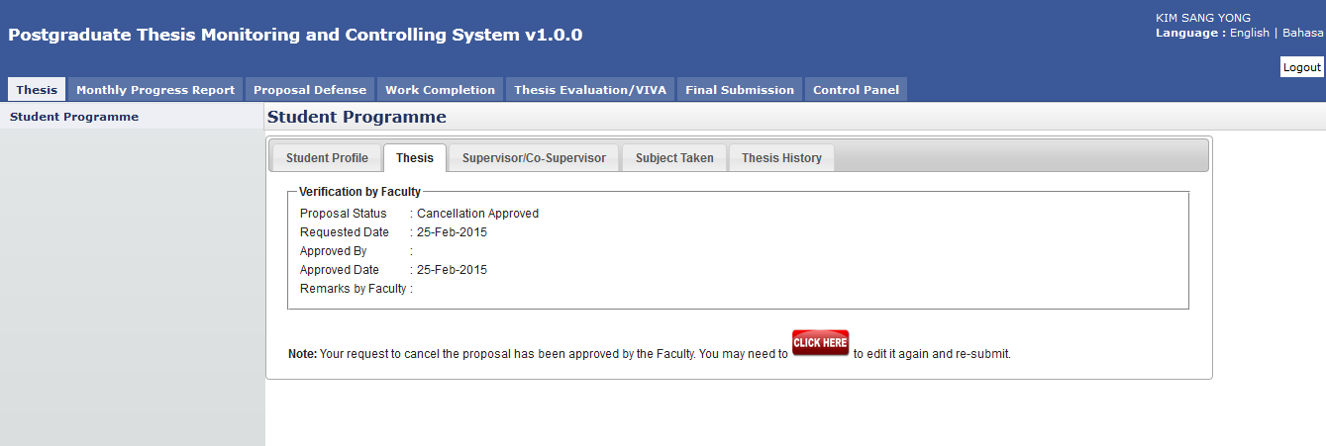

Decision by Faculty on the thesis proposal status will be appeared in here.

Figure 27: Request for Cancellation

**Steps:-**

1. Click on the **Thesis** tab on the **Top** panel
2. Click on the **Student Programme** menu on the **Left** panel
3. Click on the Thesis tab on the **Working Area**
4. System will display the notification message to the student indicate that the proposal cancellation request has been approved by the Faculty.
5. As such the student can open back the proposal via **Click Here** button and amend it accordingly.
6. The student can resubmit the proposal once the changes has been incorporated and finalized.

# EDIT PROPOSAL

## Process Flow

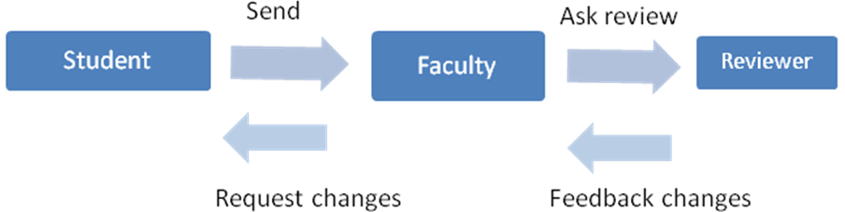

Request Changes status is can be done at level Faculty which is the process flow has gone through the Reviewer for the 2nd opinion or directly assigned to Reviewer to give a feedback.

## Request Change

If there is a case where the thesis proposal needs some changes, the Faculty will return it back to the student to amend and resubmit it.

For this scenario, the system will notify the student on the proposal status.

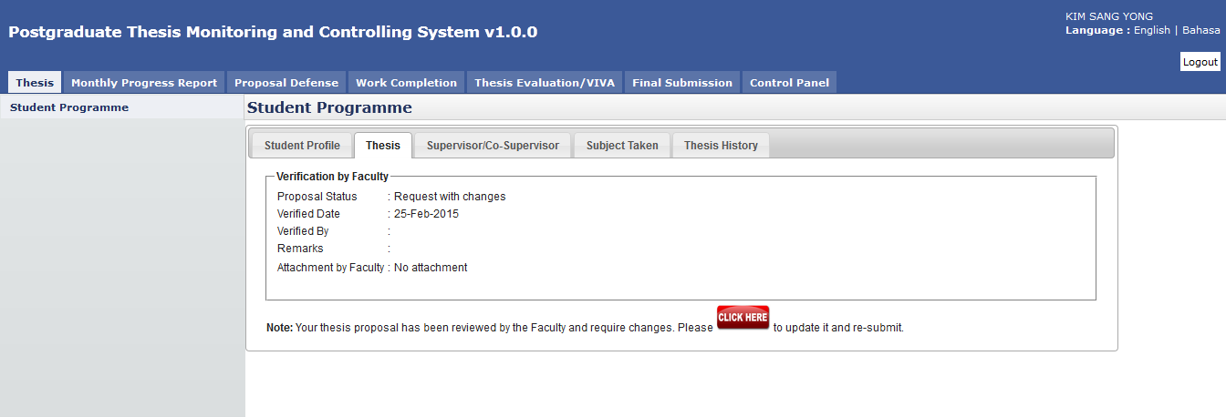

Request Changes

Figure 28: Request Changes – Edit Proposal

**Steps:-**

1. After the proposal has been submitted to the Faculty, the Faculty will review it and determine its status. In case the proposal need some changes, the student can check it via **Thesis** tab.
2. Click Thesis tab on **Top** panel
3. Click on the **Student Programme** on the **Left** panel
4. Click on the **Thesis** Tab on the **Working Area** section.
5. The system will show the proposal status and the student can read the **Remarks** and download the **Attachment** from Faculty (if any).
6. For this case, the student can amend the proposal according to the advice given by the Faculty.
7. Click on the **Click Here** button to change and resubmit it.

# VIEW PROPOSAL

## Process Flow

1. Approve

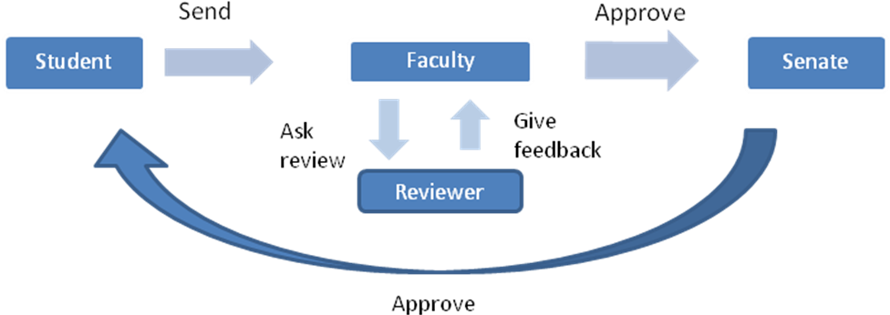

Above scenario, after student sent the thesis proposal, Faculty will ask Reviewer to review the thesis proposal and give a feedback to Faculty to review before approve the thesis proposal.

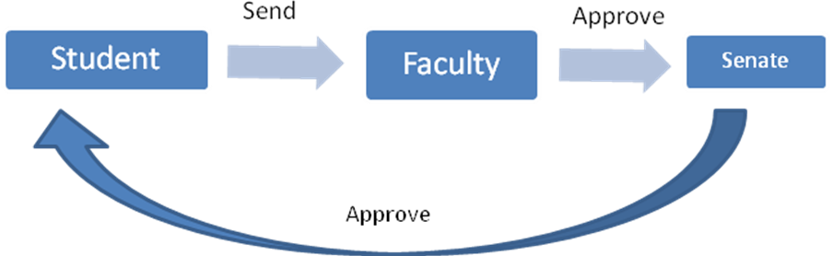

Others scenario, Faculty is not necessary ask review from Reviewer before approve, they also can approve the thesis proposal then submit to Senate for endorsement.

1. Approve with Changes

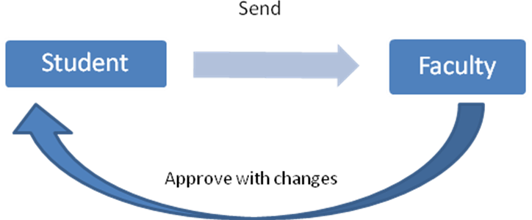

Approve with changes also can be done by the Faculty if the thesis proposal approve with changes. Status approve with changes is also not necessary need to be done by Senate endorsement.

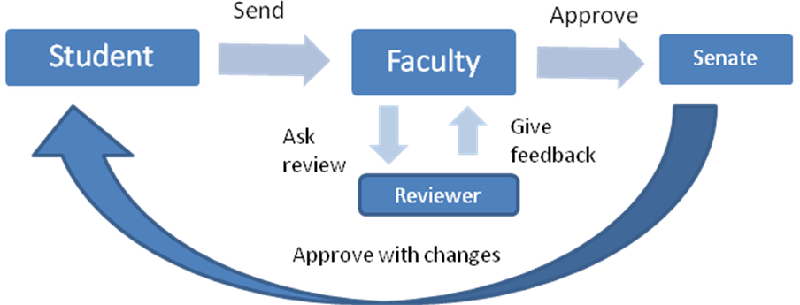

Approve with changes also can through the others process which is Faculty has decide Reviewer give a feedback within the time frame given before Senate endorse. Remark or feedback also can be viewing by Senate roles before Senate endorse the thesis proposal Approve with changes.

## Approved

The student can view back the proposal once it has been approved by the Senate.

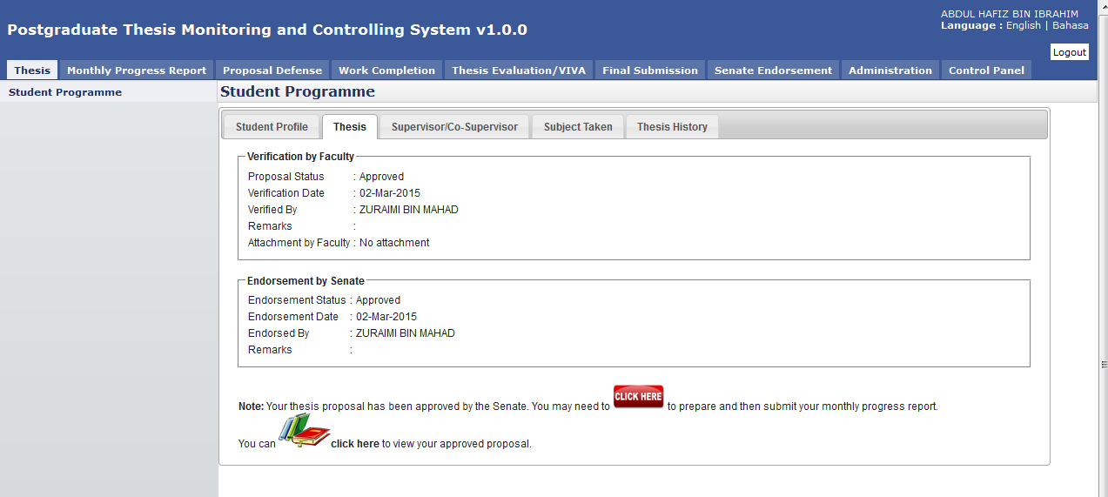

View the proposal after the Senate has approved it.

Figure 29: View Proposal – Approved by Senate

**Steps:-**

1. Click on the **Thesis** tab on the **Top** panel
2. Click on the **Student Programme** menu on the **Left** panel
3. Click on the **Thesis** tab on the **Working Area**
4. System will display the notification message to the student indicate that the proposal has been approved by the Faculty and Senate.
5. The student can proceed with the monthly progress report preparation via **Click Here** button .
6. Or the student can view the approved proposal via the click here button  No amendment is allowed on this view.

## Approved with Changes

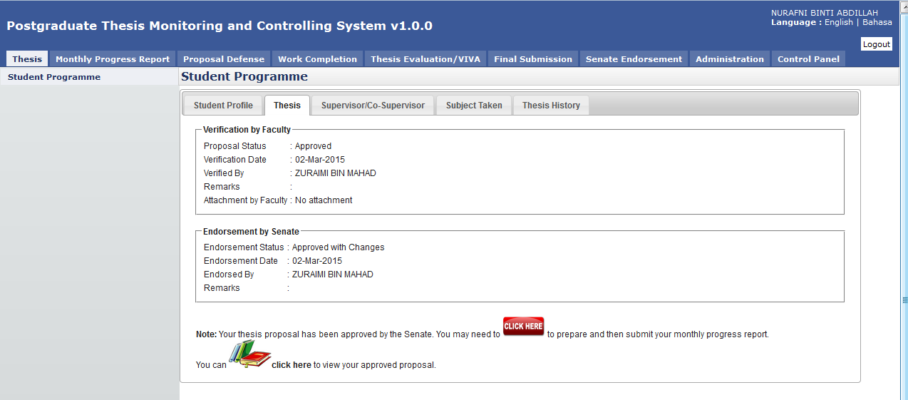

View the proposal after the Senate has approved it (with changes).

Figure 30: View Proposal – Approved with Changes by Senate

**Steps:-**

1. Click on the **Thesis** tab on the **Top** panel
2. Click on the **Student Programme** menu on the **Left** panel
3. Click on the **Thesis** tab on the **Working Area**
4. System will display the notification message to the student indicate that the proposal has been approved (with changes) by the Faculty and Senate.
5. The student can proceed with the monthly progress report preparation via **Click Here** button .
6. Or the student can view the approved proposal via the click here button  No amendment is allowed on this view.

# Monthly Progress Report

## Thesis Chapter

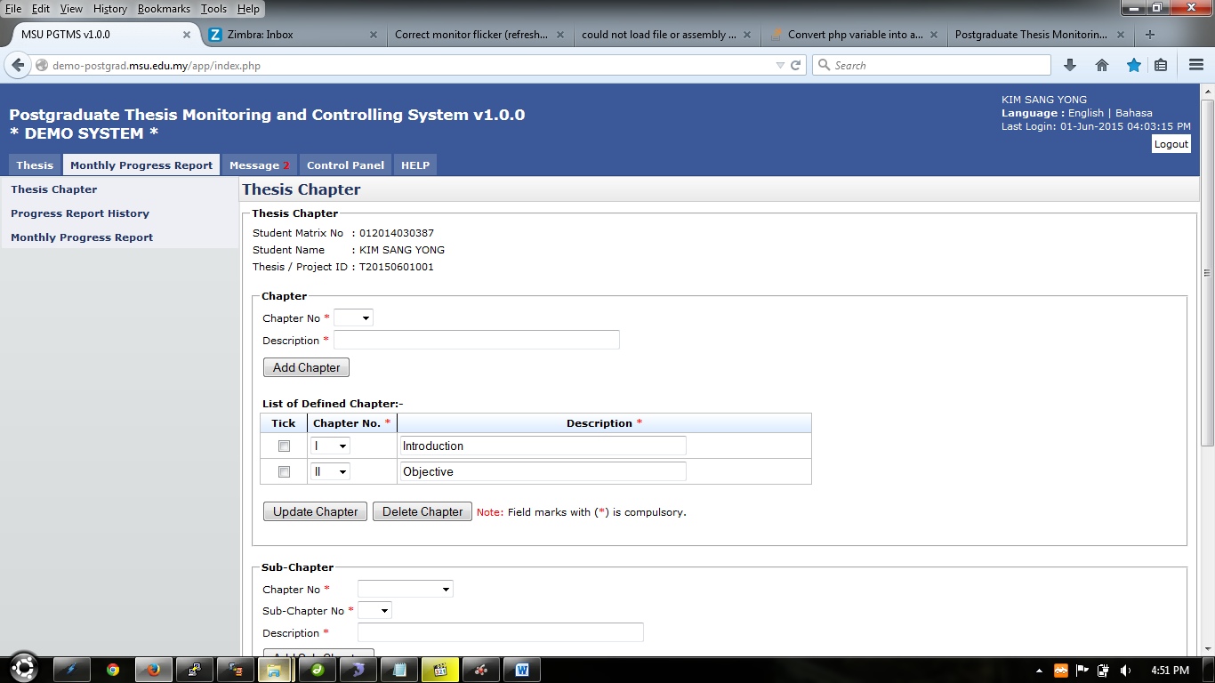

Figure 31:Thesis Chapter

**Pre-condition**

1. After approval by senate

**Post-condition**

1. Can create chapter and sub-chapter
2. Chapter and sub-chapter can be delete and update

**Steps:-**

1. Click on the **Monthly Progress Report** tab on the **Top** panel
2. Click on the **Thesis Chapter** menu on the **Left** panel
3. System will display the thesis chapter that need to be create byuser.
4. Under **Chapter** category

### Add Chapter



Figure 32: Add Chapter

**Pre-condition**

1. The proposal must be approved by the Senate

**Post-condition**

1. Chapter can be updated or deleted
2. Sub-chapter can be created
3. The monthly progress report can be submitted

**Steps:-**

1. To add chapter , choose chapter number on the field provided (refer figure 33)
2. Then insert description of the chapter in the text field provided(refer figure 34)
3. Click **Add Chapter** button to proceed.

Choose Chapter Number

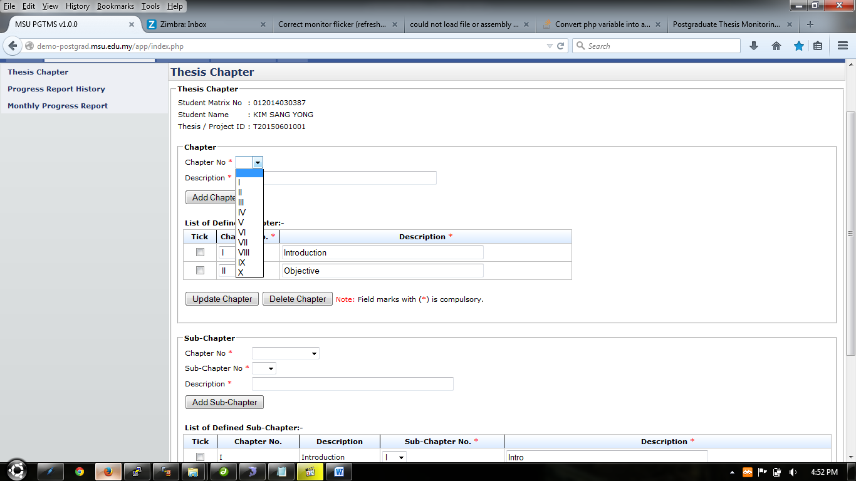

Figure 33:Chapter No

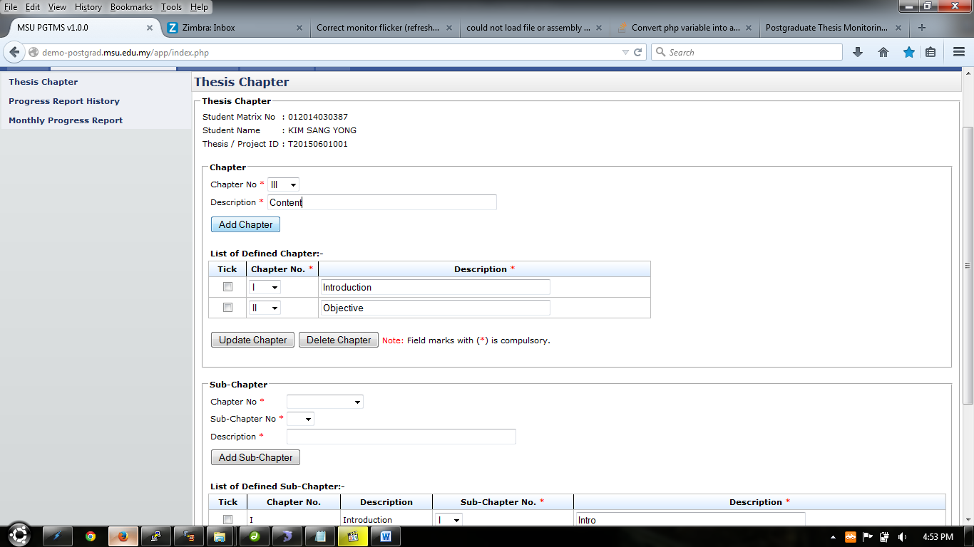

Insert Chapter Description

Figure 34:Add Chapter

### Update Chapter

Description field

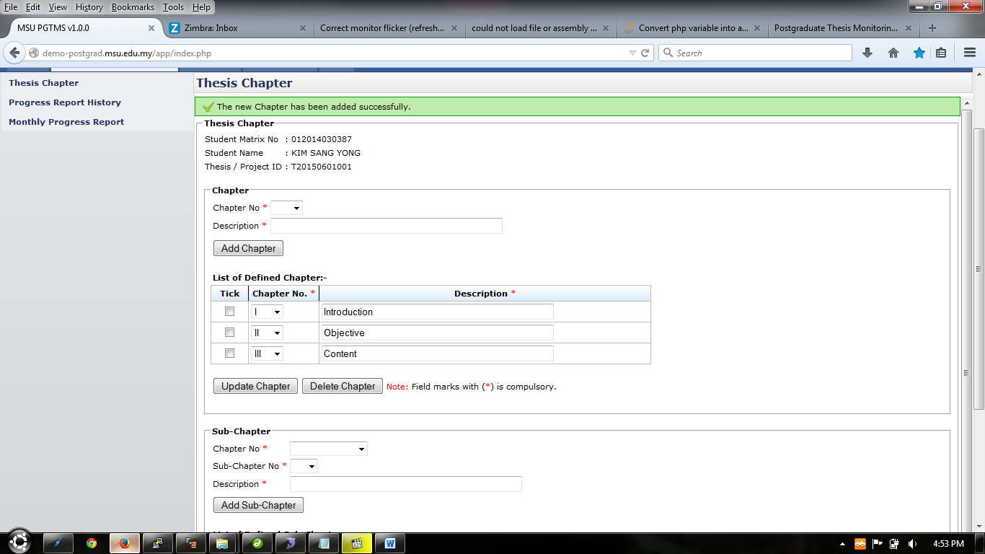

Figure 35: Update Chapter

**Pre-condition**

1. Chapter should be created first

**Post-condition**

1. Chapter can be updated again
2. Chapter can be deleted

**Steps:-**

1. To update chapter , choose chapter number on the field provided (refer figure 35)
2. Then change description of the chapter in the text field provided(refer figure 35)
3. Tick the checkbox of the chapter
4. Click **Update Chapter** button to proceed.

### Add Sub-Chapter

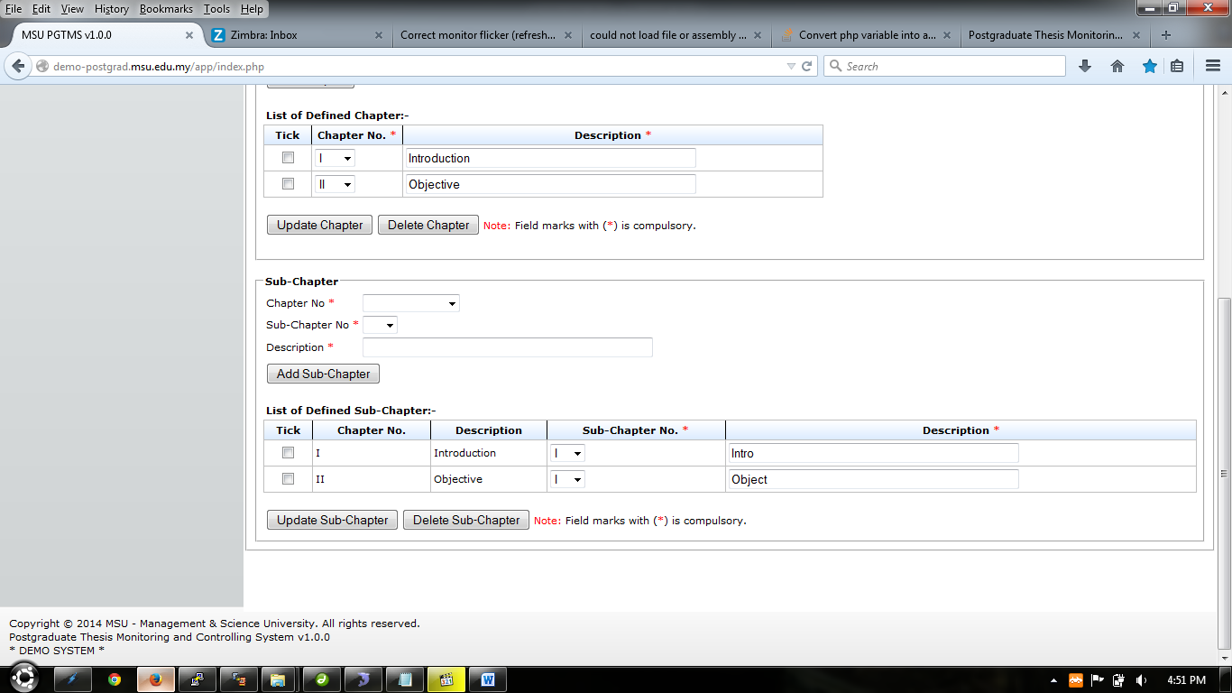

Figure 36: Add Sub-Chapter

**Pre-condition**

1. The chapter must be created first

**Post-condition**

1. Sub-chapter can be updated or deleted

**Steps:-**

1. To add sub-chapter , choose chapter number on the field provided (refer figure 37)
2. Choose sub-chapter number on the field provided (refer figure 38)
3. Then insert description of the sub-chapter in the text field provided(refer figure 39)
4. Click **Add Sub Chapter** button to proceed.

Choose Chapter Number

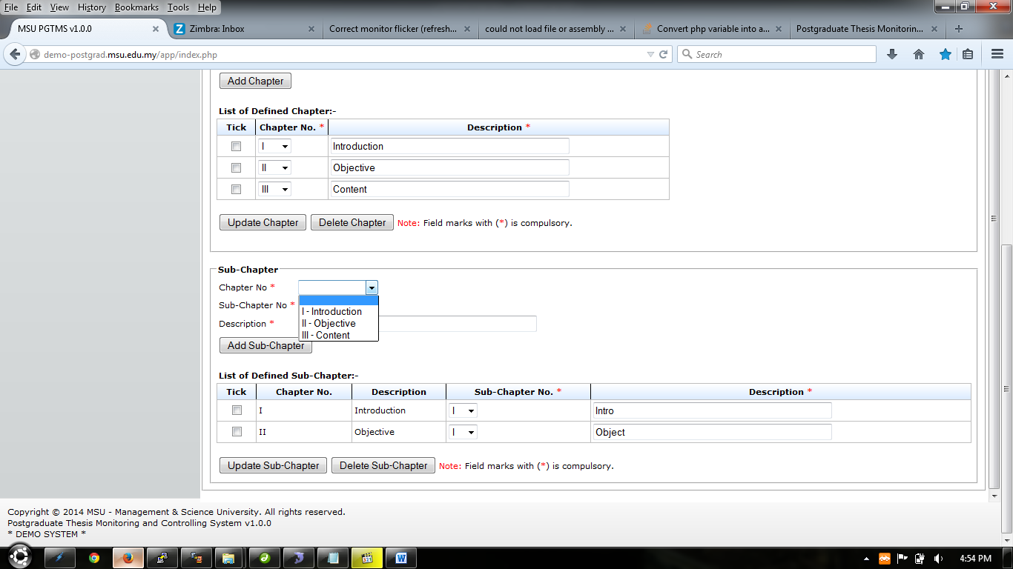

Figure 37: Chapter No

Choose Sub-Chapter Number

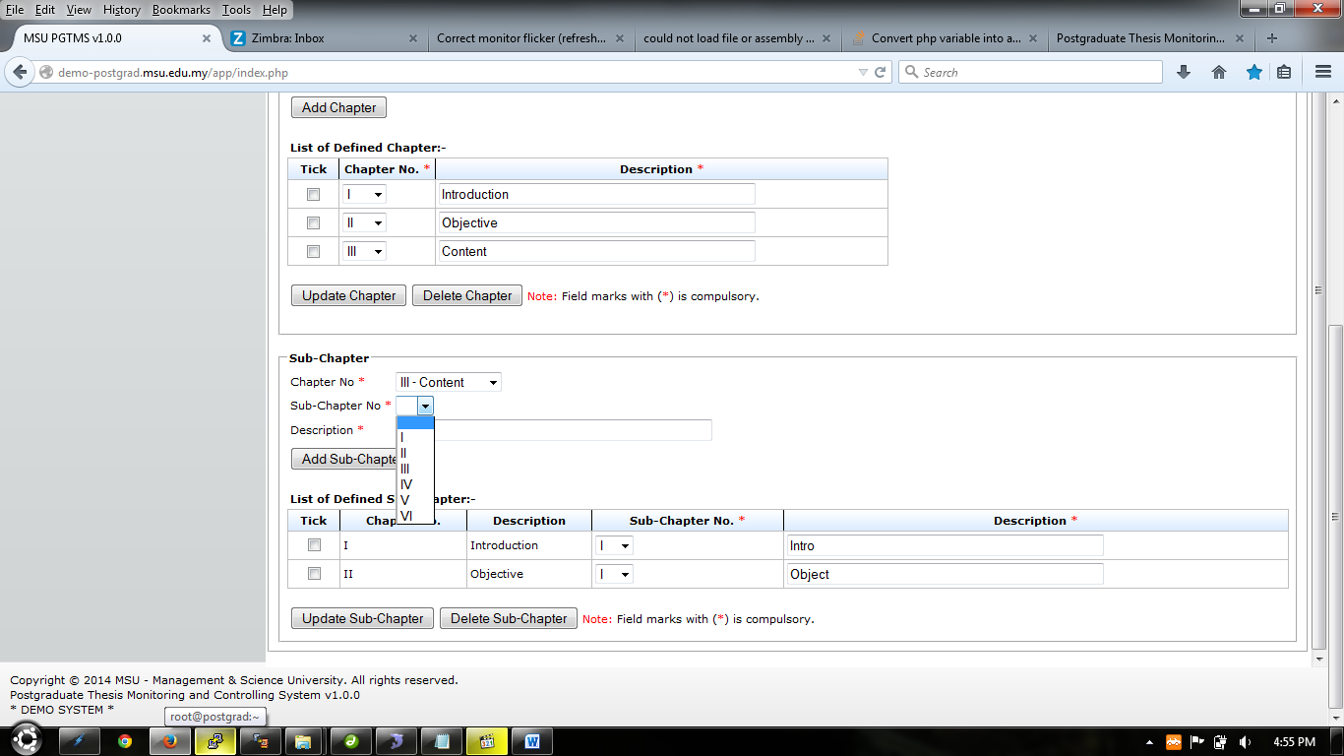

Figure 38: Sub-Chapter No

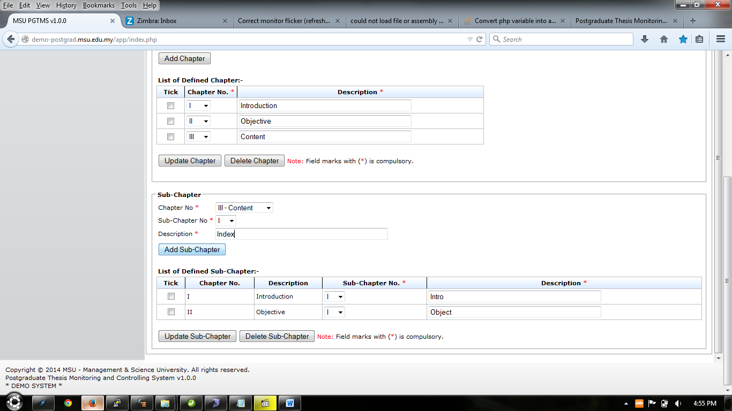

Insert Sub-Chapter Description

Figure 39: Add Sub-Chapter

### Update Sub-Chapter

Description field

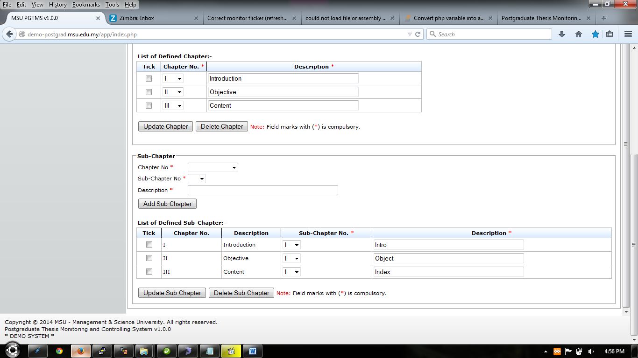

Figure 40: Update Chapter

**Pre-condition**

1. Sub-Chapter should be created first

**Post-condition**

1. Sub-Chapter can be updated again
2. Sub-Chapter can be deleted

**Steps:-**

1. To update sub-chapter , choose sub-chapter number on the field provided (refer figure 40)
2. Then change description of the sub-chapter in the text field provided(refer figure 40)
3. Tick the checkbox of the sub-chapter
4. Click **Update Sub-Chapter** button to proceed.

## Monthly Progress Report

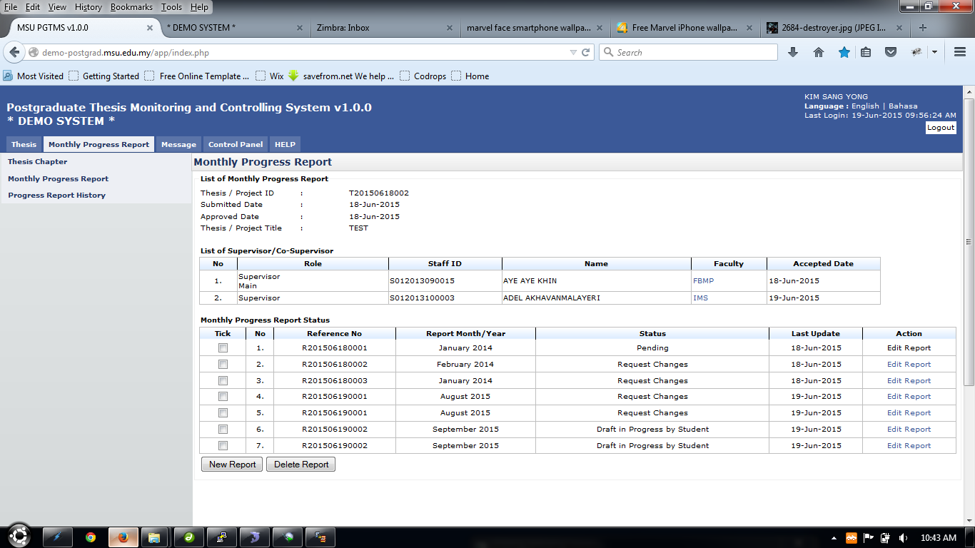

New Report Button

Delete report button

Tick

Figure 41: Monthly Progress Report

**Pre-condition**

1. After approval by senate
2. After supervisor/co-supervisor accept invitation

**Post-condition**

1. Monthly progress report can be submit
2. Condition to delete report is the status of the report is “Draft in Progress By Student”.

**Steps:-**

1. Click on the **Monthly Progress Report** tab on the **Top** panel
2. Click on the **Monthly Progress Report** menu on the **Left** panel
3. System will display the detail regarding monthly progress report.
4. To proceed, click **New Report** button.
5. To delete, tick on the checkbox on the left side of the table shown above (**Tick** column) and click **Delete Report** button.

### New Progress Report

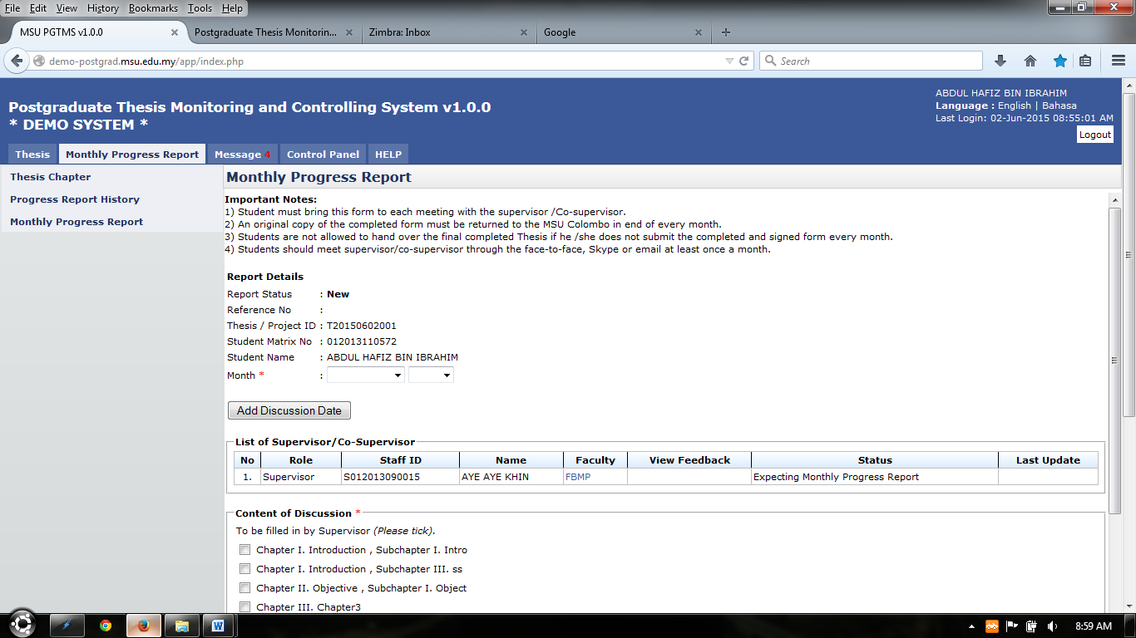

Monthly Progress Report

Progress Report History

Figure 42: New Report

**Pre-condition**

1. The proposal must be approved by the Senate
2. Supervisor/Co-Supervisor need to accept invitation first

**Post-condition**

1. New progress report can be made
2. The progress report submitted can be view at **Progress Report History**
3. Wait for the supervisor to respond the monthly progress report

**Steps:-**

1. System will display all necessary field that need to be field in by user (refer figure 42, 43, 44)
2. System also will display list of supervisor/co-supervisor assigned (refer figure 42)
3. Tick on the chapter of the progress report based on the discussion (refer figure 43)
4. Then insert necessary detail regarding progress report in the field provided(refer figure 43,44)
5. Add discussion date (refer 12.2.1.1 Add Discussion Date)
6. Add Attachment (refer 12.2.1.2 Add Attachment)
7. To save progress report before submitting, click **Save** button
8. To submit progress report, click **Submit** button. (refer figure 44)
9. After done submitting, system will be display shown on figure 57
10. The email notification also be triggered to the supervisor (refer Appendix)

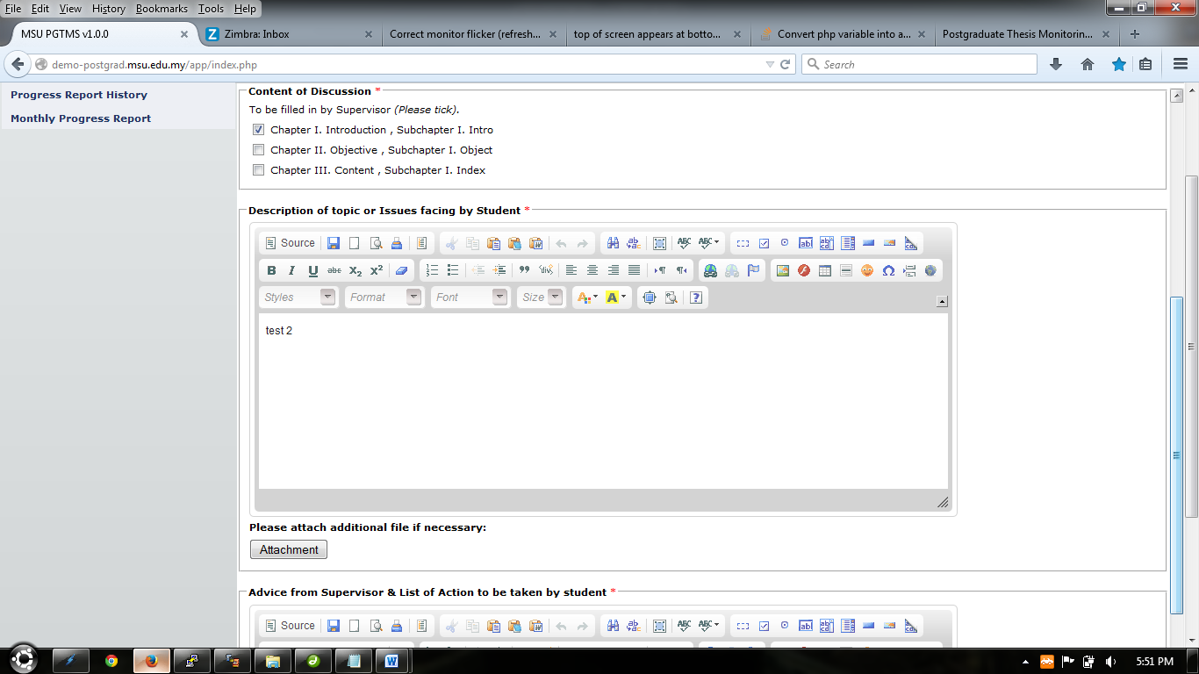

Insert Description of issues face by student

Choose Chapter Number

Figure 43:

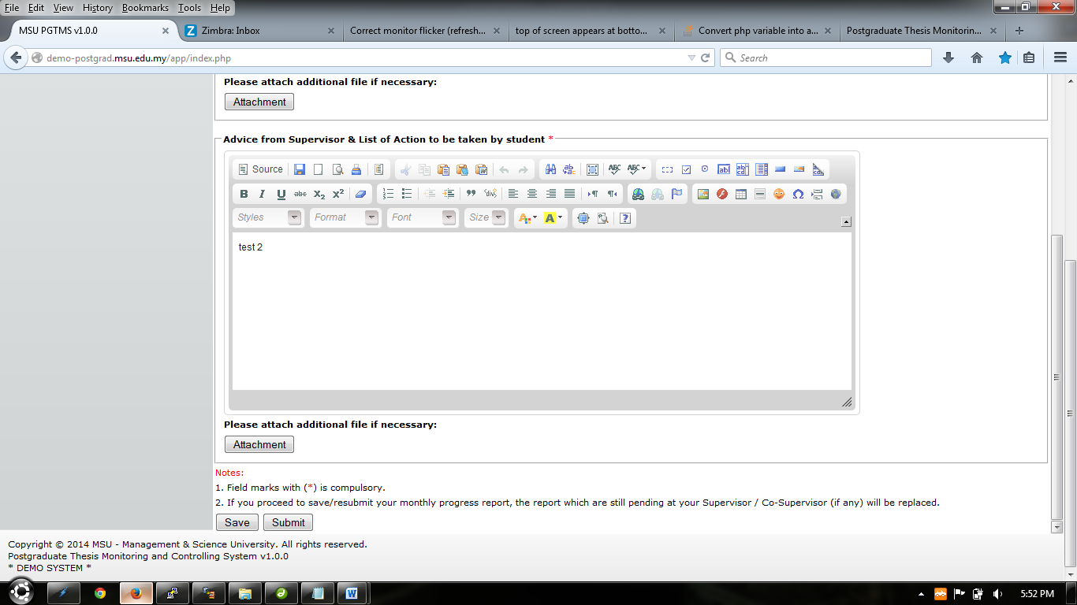

Insert advice from supervisor and action taken by student

Figure 44:

#### Add Discussion Date

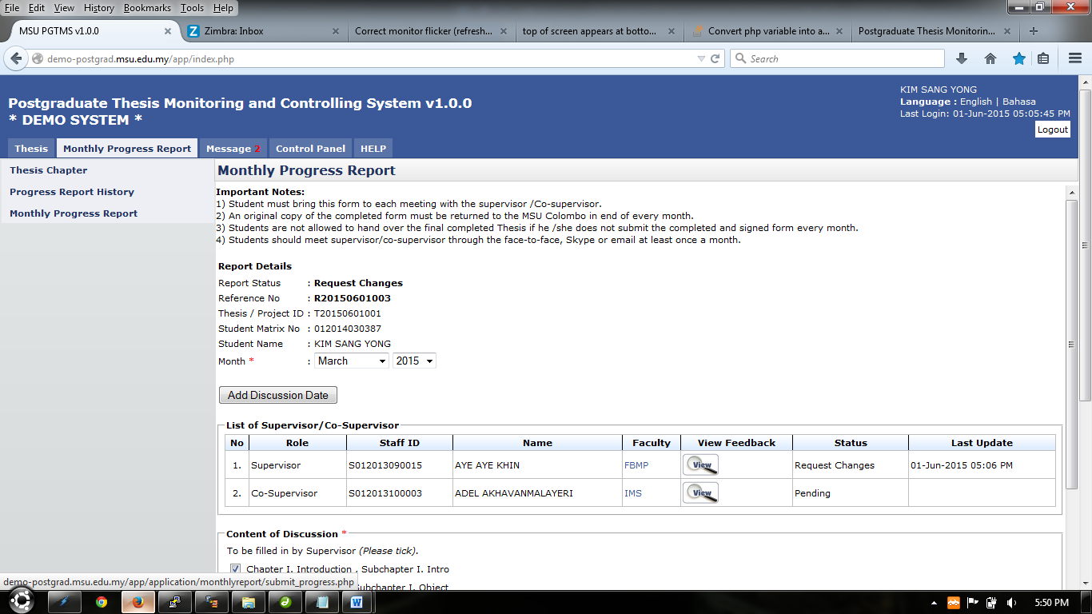

Figure 45: Add Discussion Date

**Steps:-**

1. Click on **Add Discussion Date** button provided to add date of discussion (refer figure 45)

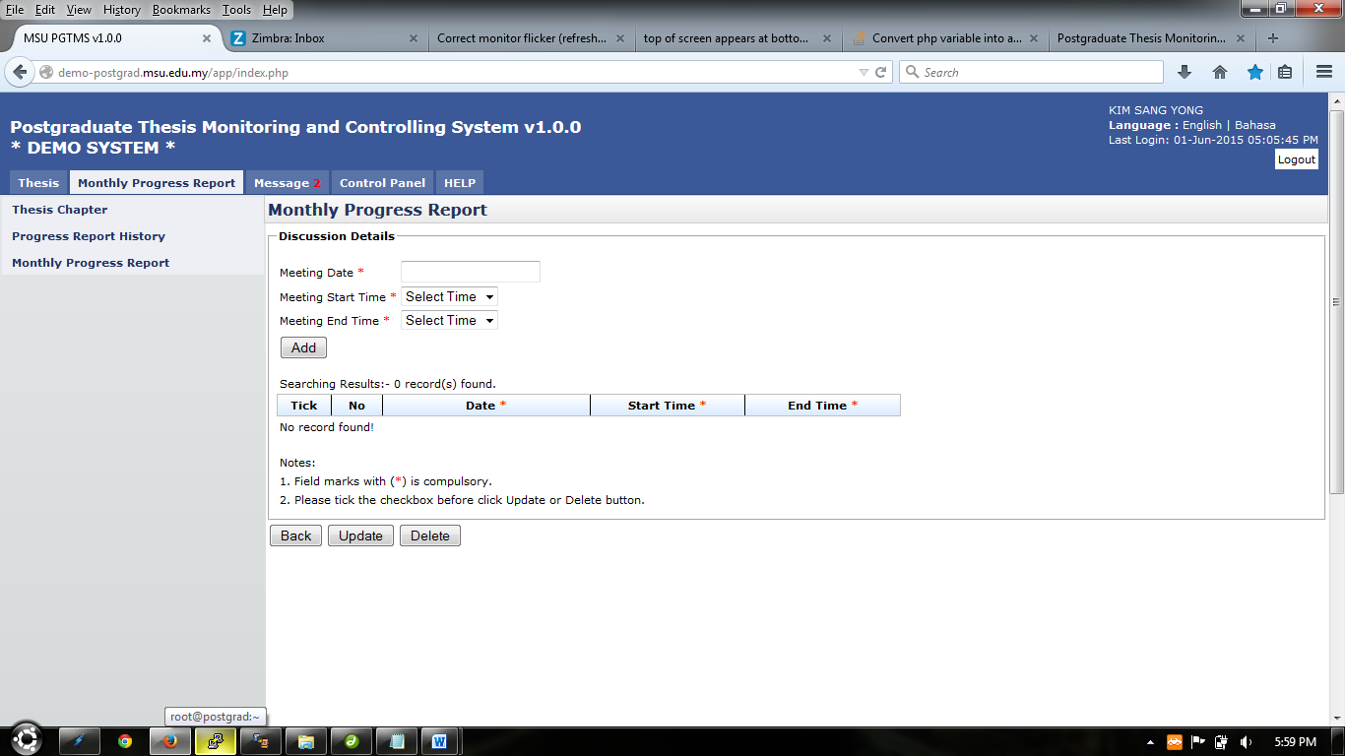

Figure 46: Discussion Date

1. Choose Meeting date, Meeting start time and Meeting End Time (refer figure 46, 47 & 48)
2. Click **Add** button to proceed
3. To Edit discussion date, choose **Date, Start Time or End Time** and tick on the checkbox
4. Click **Update** button to proceed
5. To Delete discussion date, tick on the checkbox of the discussion date and click **Delete** button to proceed
6. To go back to the previous page, click **Back** button

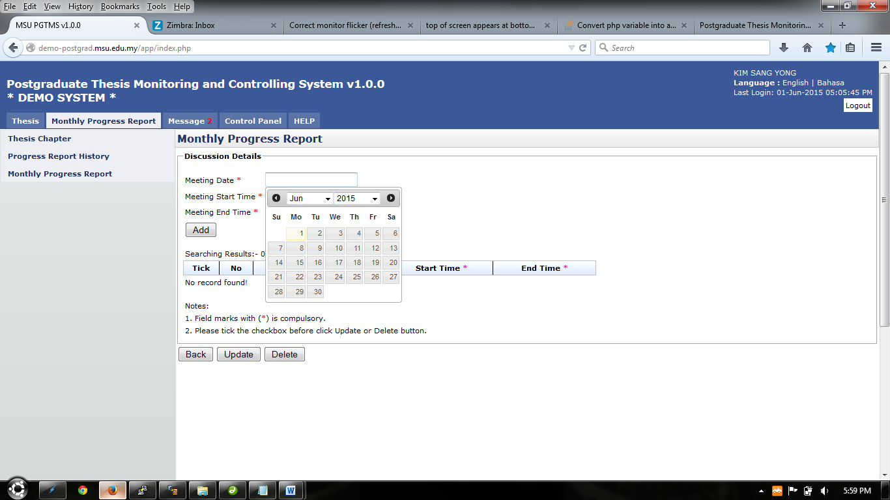

Figure 47: Meeting Date

Meeting Date

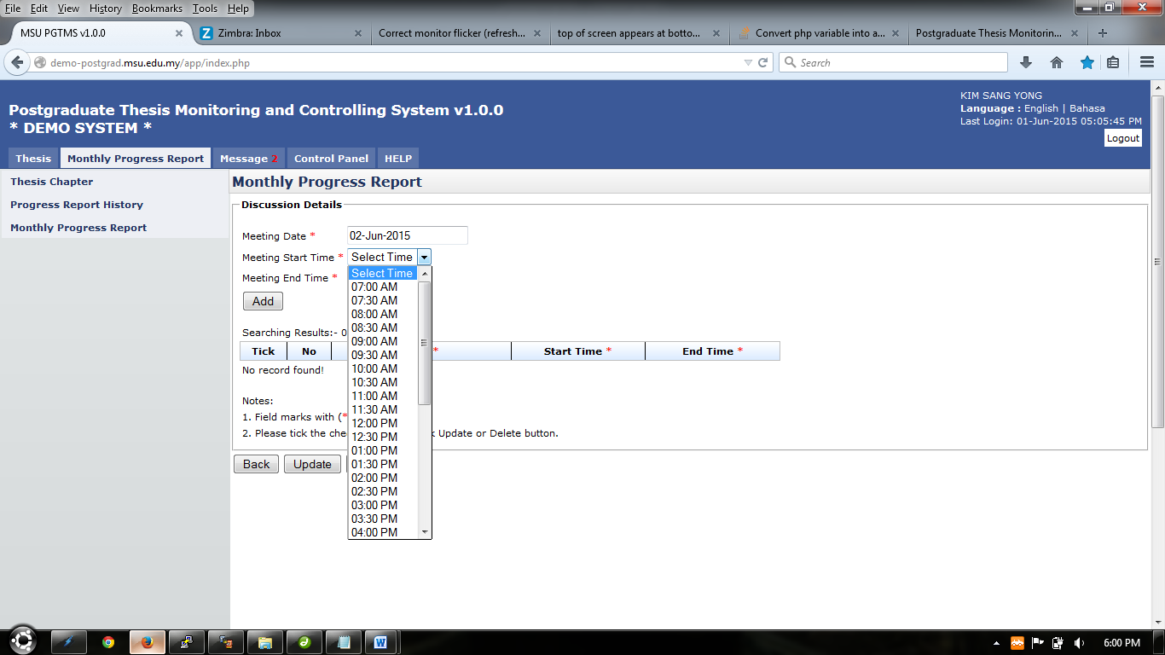 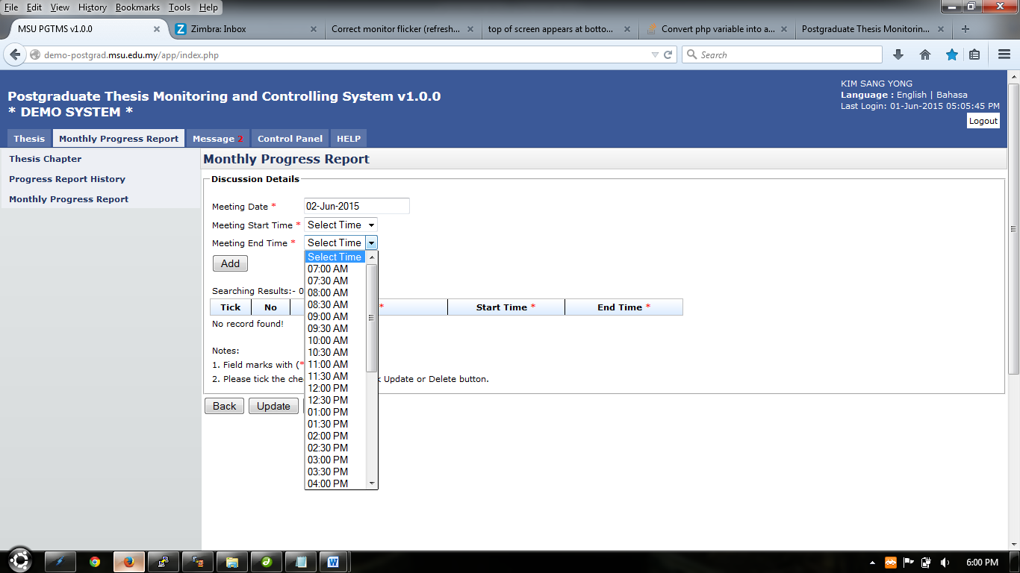

Meeting End Time

Meeting Start Time

Figure 48: Meeting Start & End Time

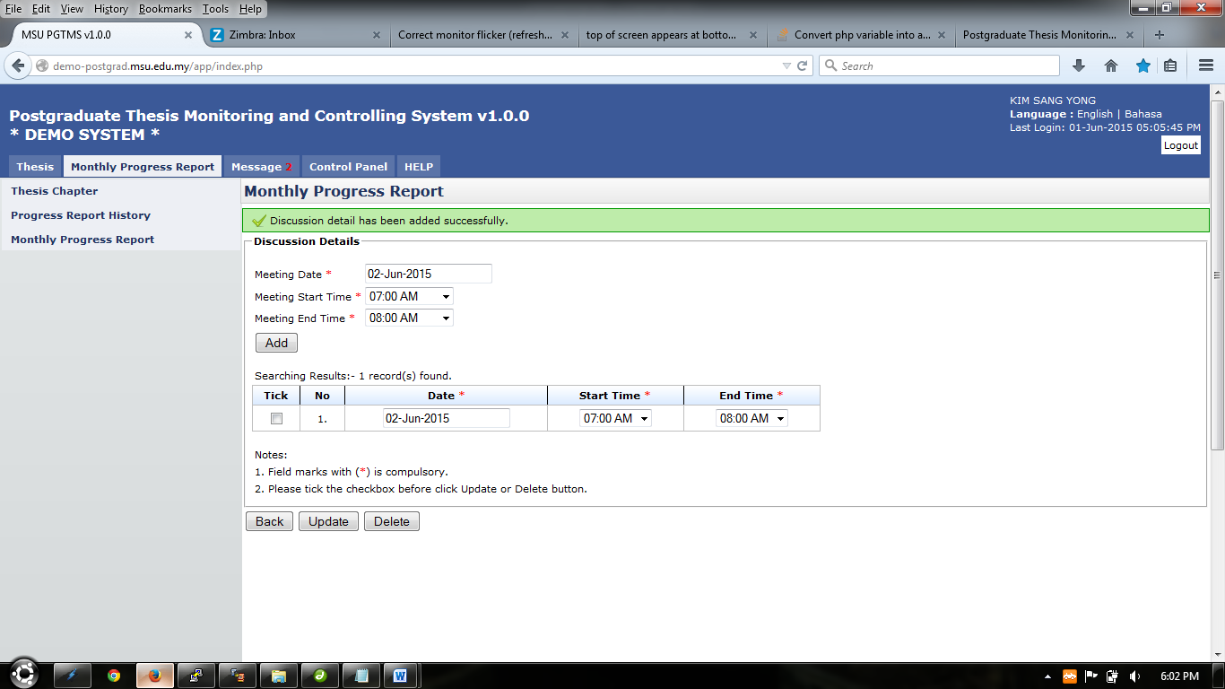

Figure 49: Edit/Delete Discussion Date

#### Add Attachment





Figure 50: Add Attachment

**Steps:-**

1. Click on **Attachment** button provided to add attachment of issue facing by student or advice from supervisor (refer figure 50)

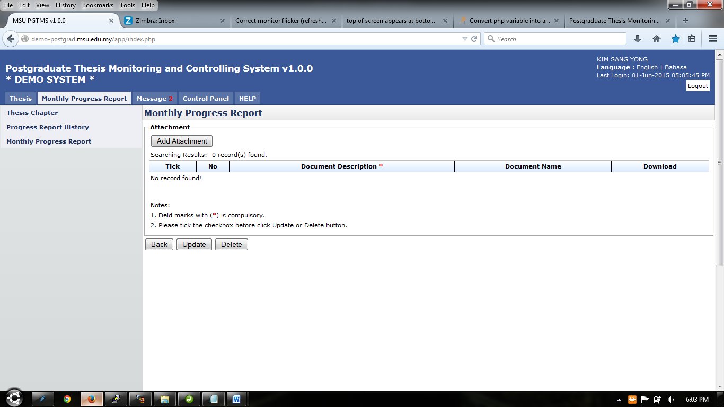

Figure 51: Add Attachment

1. Click **Add Attachment** button (refer figure 51, 47 & 48)
2. Popup display shown on figure 52 will be shown.
3. Click **Browse** button and popup show on figure 53 will be shown and choose necessary attachment to upload. Then click **Open** button to confirm attachment chosen.
4. Enter file description on the field provided (refer figure 52)
5. Click **Insert Attachment** to proceed
6. Popup show on figure 54 will be shown, click **Done** button to proceed

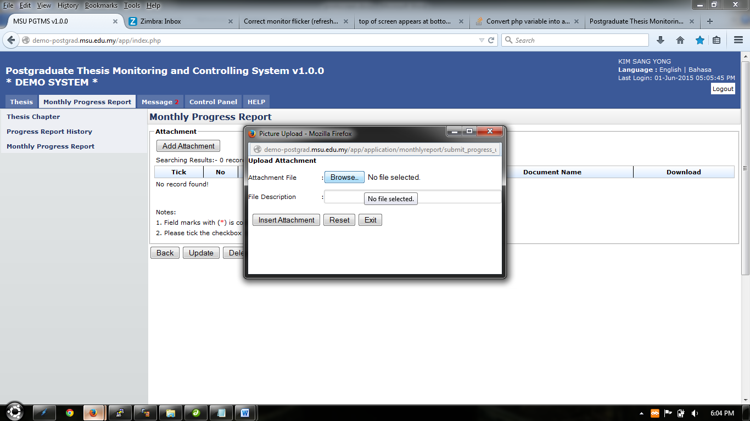

Figure 52: Browse

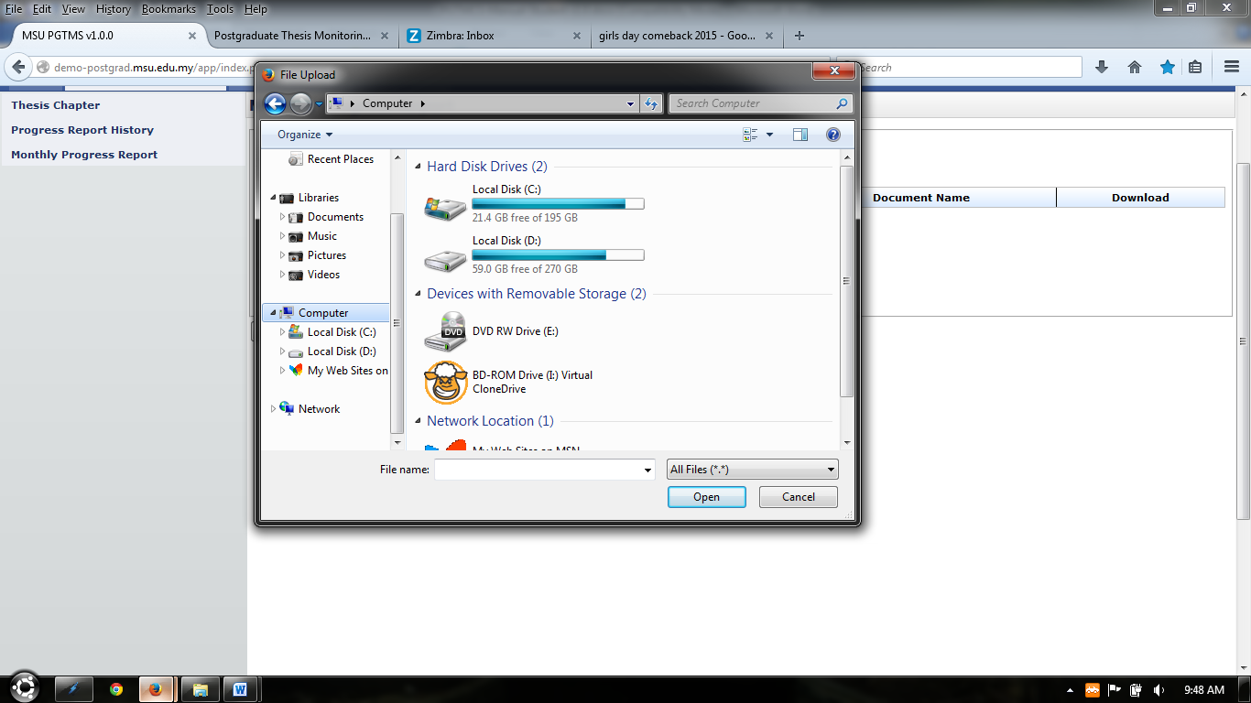

Figure 53: Choose Attachment

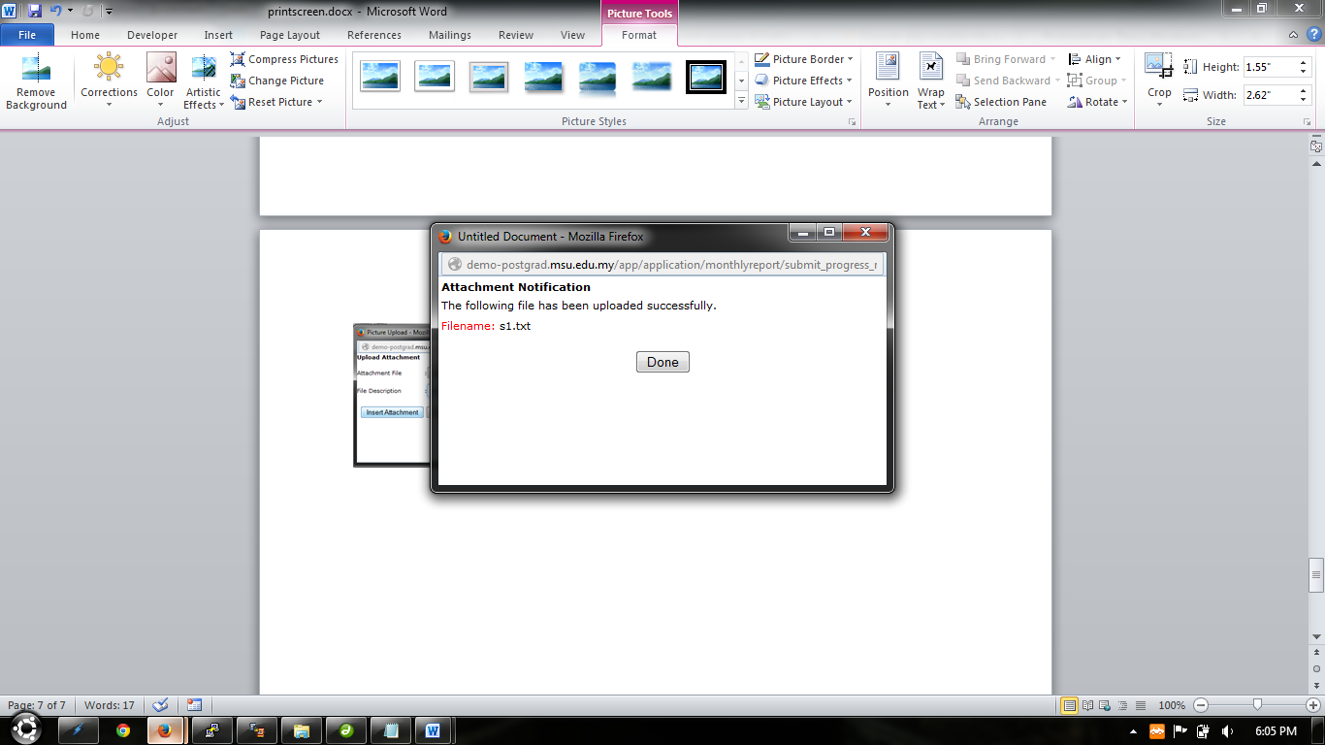

Figure 54: Finish Upload

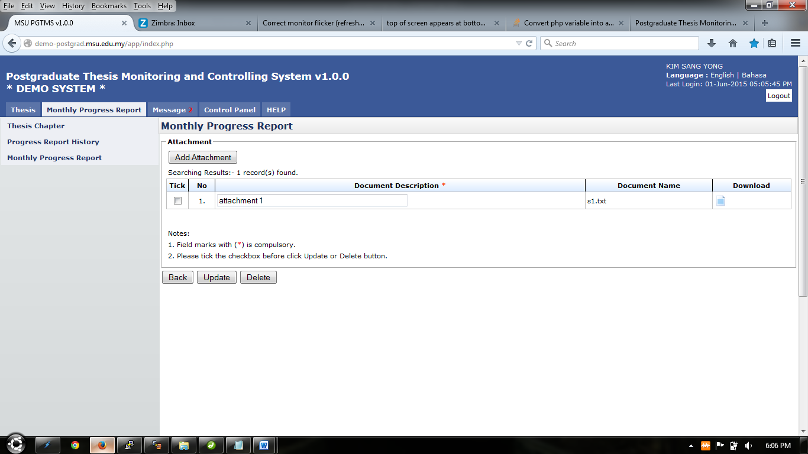

Figure 55: List of attachment

1. To update attachment description, change necessary description on the field, tick on the checkbox on the far left side. Then click **Update** button to proceed.
2. To delete attachment, tick on the checkbox on the far left side and click **Delete** button to delete.
3. To download or open attachment uploaded, click to download or open attachment.
4. To go back to previous page, click **Back** button.
5. The previous page will show how many attachment that has been uploaded at the **Attachment** button. (refer figure 56)

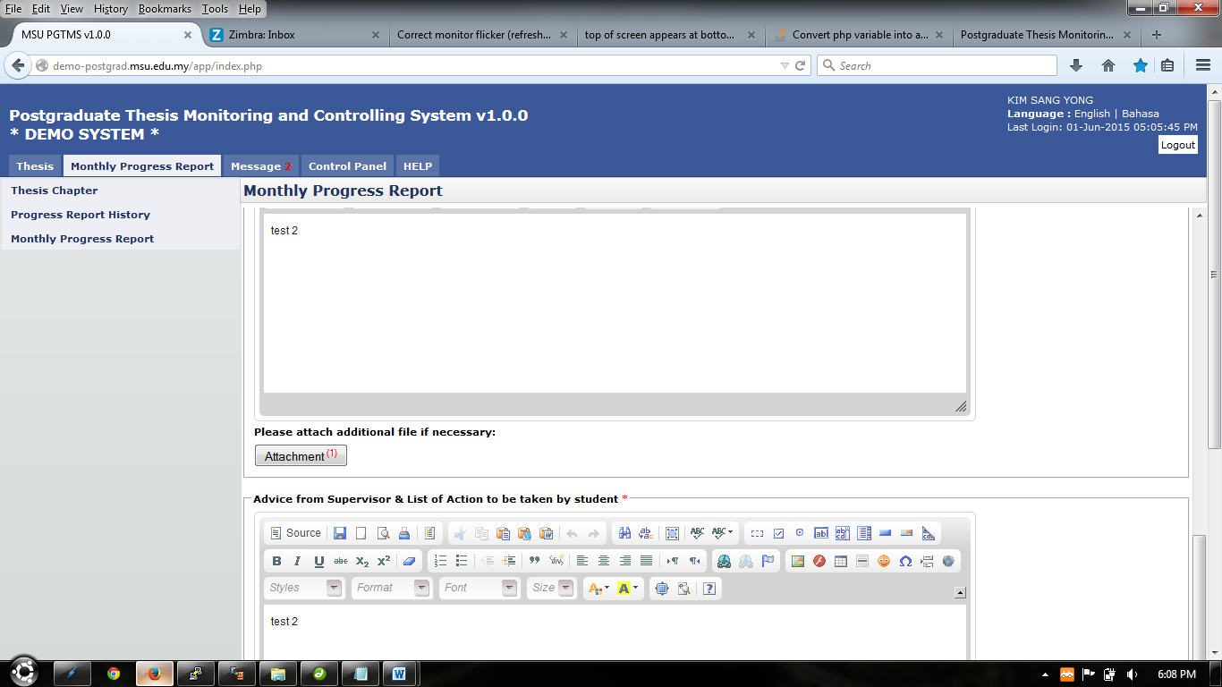

Figure 56: Finish uploading

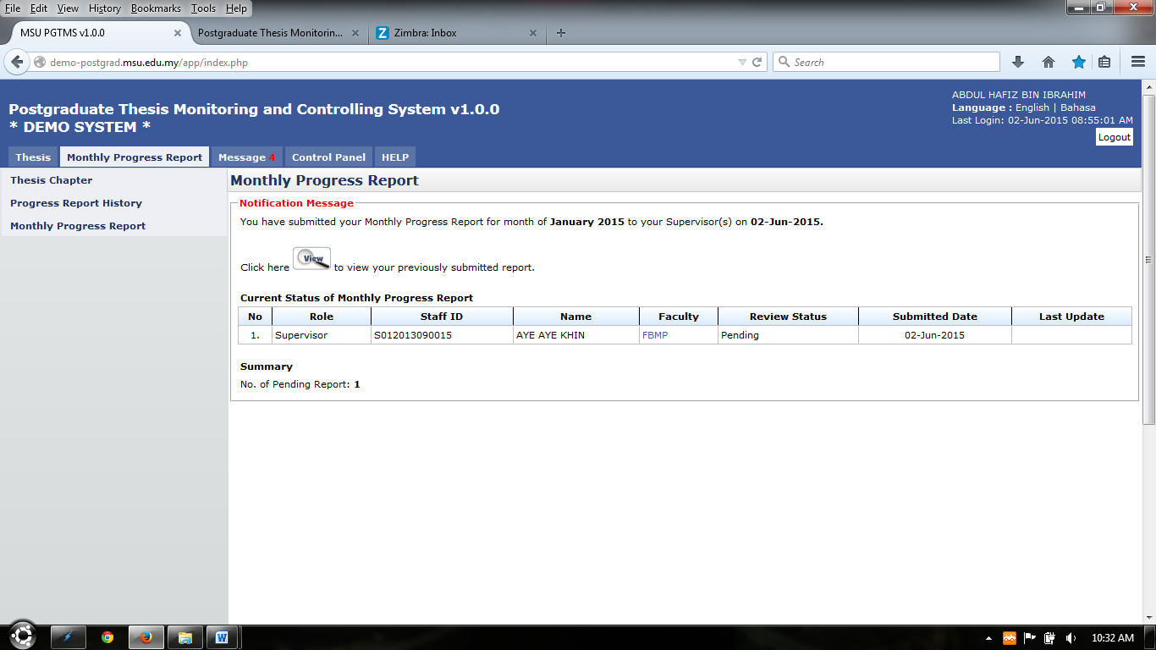

Figure 57: Finish Submitting

**Steps:-**

1. The system will be display the status of the progress report submitted.
2. To view previous report, click on 

#### Request Changes

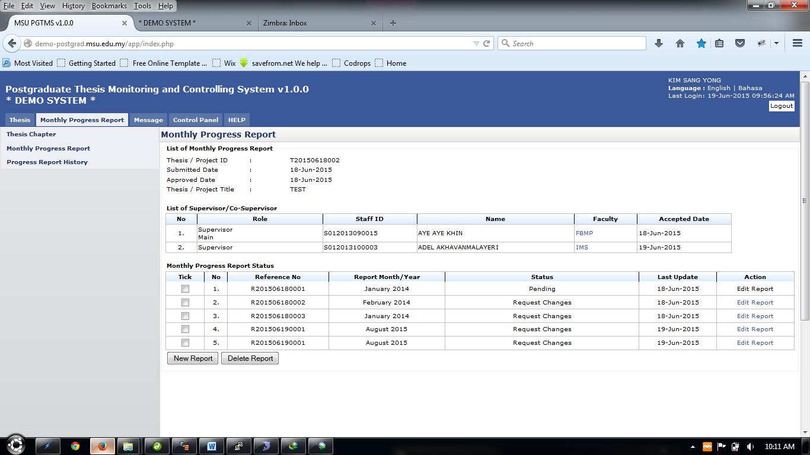

Figure 58: Edit Report

**Pre-condition**

1. After supervisor review monthly progress report

**Post-condition**

1. Change or repair report that has been reviewed

**Steps:-**

1. Click on the **Edit Report** link on the far right side of the table shown in figure 58, under the **Action** column.

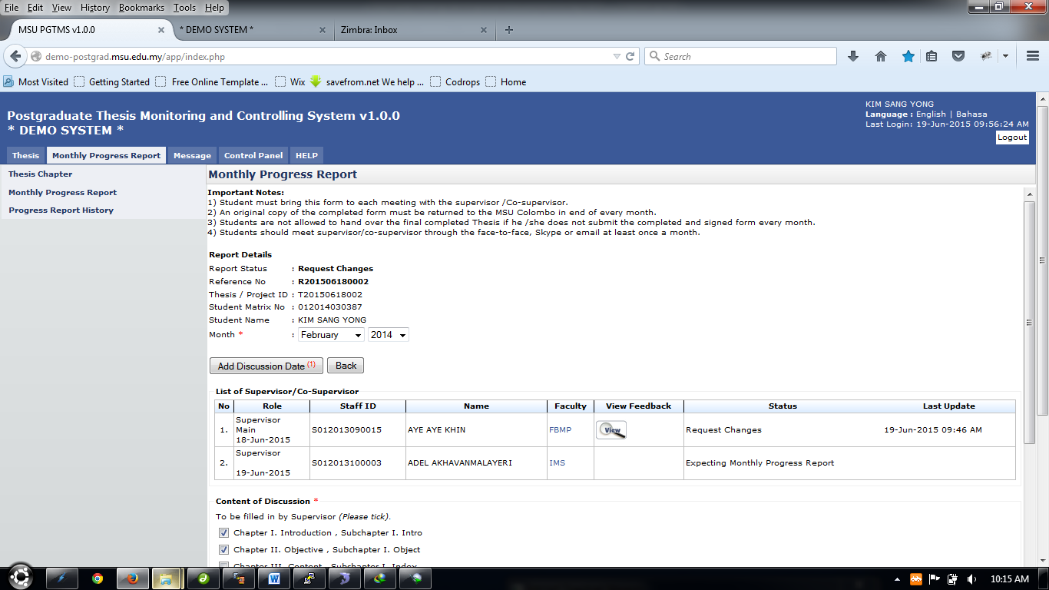

Figure 59: Edit Report

**Steps:-**

1. Click on the  to view feedback from supervisor.
2. Then edit necessary detail for the monthly progress report, or repeat step in **New Progress Report.**
3. After finish, click **Submit** button to submit. Click **Save** button to save as draft.

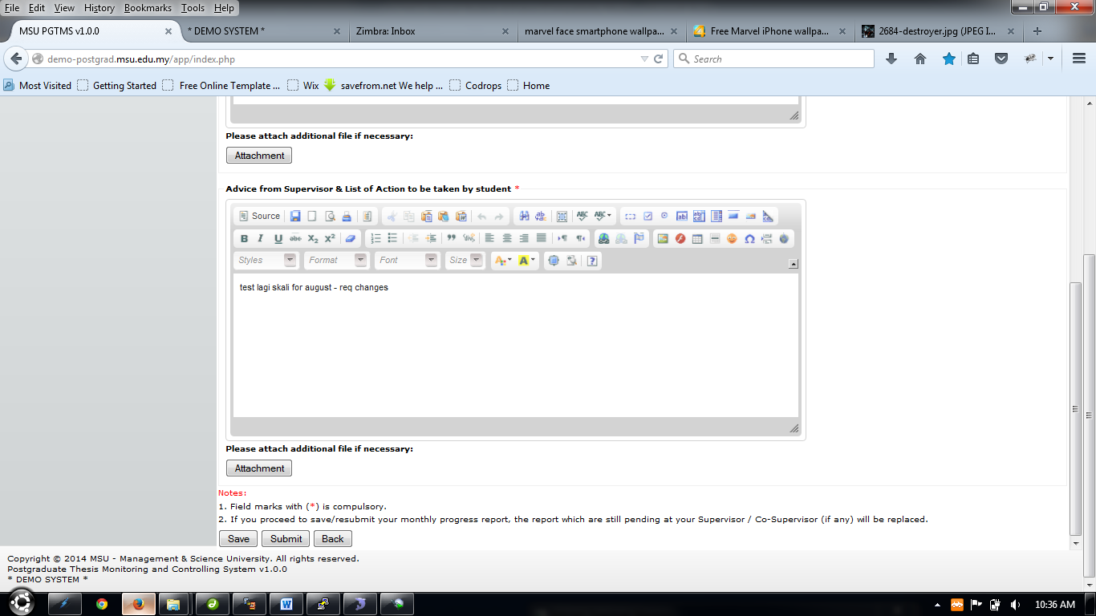

Figure 60: Edit Report

## Progress Report History

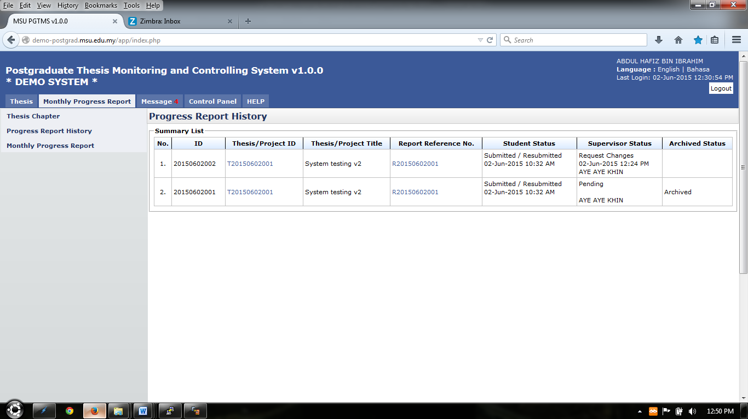

Figure 61: List of Progress Report History

**Pre-condition**

1. After student submit progress report

**Post-condition**

1. Can view progress report history

**Steps:-**

1. Click on the **Monthly Progress Report** tab on the **Top** panel
2. Click on the **Progress Report History** menu on the **Left** panel
3. System will display all the list of progress report history
4. To view thesis detail, click on the link at thesis/project id column(refer figure 61)
5. To view progress report detail, click on the link at **Report Reference No.** column (refer figure 58)

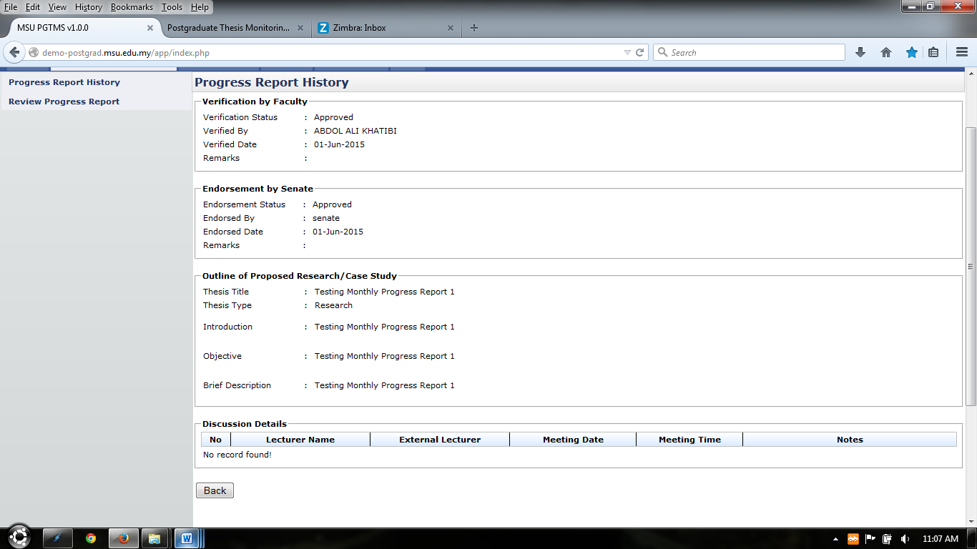

Figure 62: Thesis Detail

**Steps:-**

1. The system will display thesis detail only
2. Click **Back** button to go to previous page.

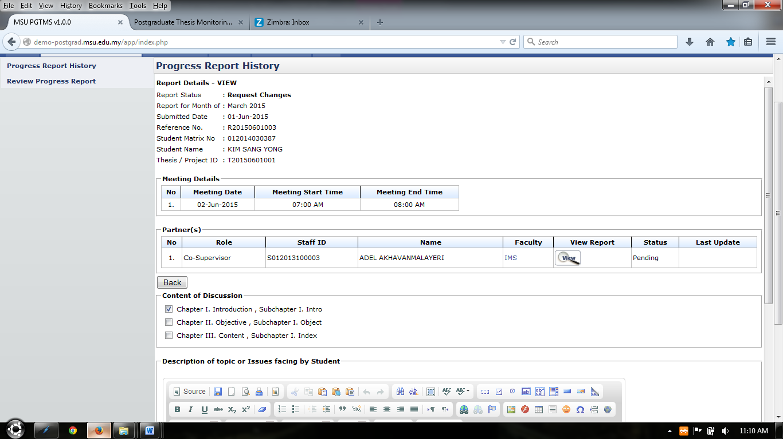

Figure 63: Progress Report History Detail

**Steps:-**

1. The system will display progress report detail only
2. To view report by supervisor/co-supervisor, click 
3. Click **Back** button to go to previous page.

# Message

## Inbox

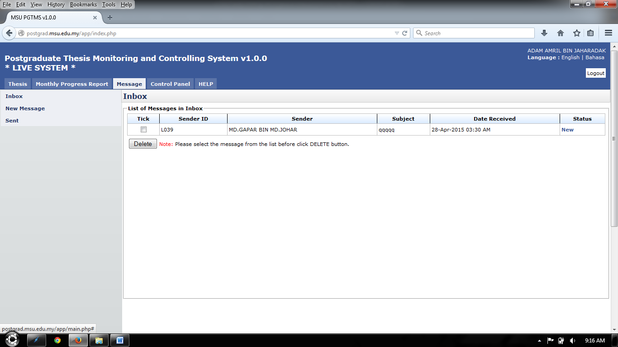

Inbox Menu

Figure 64: Message

**Steps:-**

1. Click on the **Message** tab on the **Top** panel
2. Click on the **Inbox** menu on the **Left** panel
3. System will display the list of message that been receive by user.
4. On the far right side, it will display the status of the message whether is **New** or **Read**
5. To read the message, click on the link on the right side which is in **Status** column. (Refer View Message)
6. To delete message, tick on the checkbox in **Tick** column, and click **Delete** button

### View Message

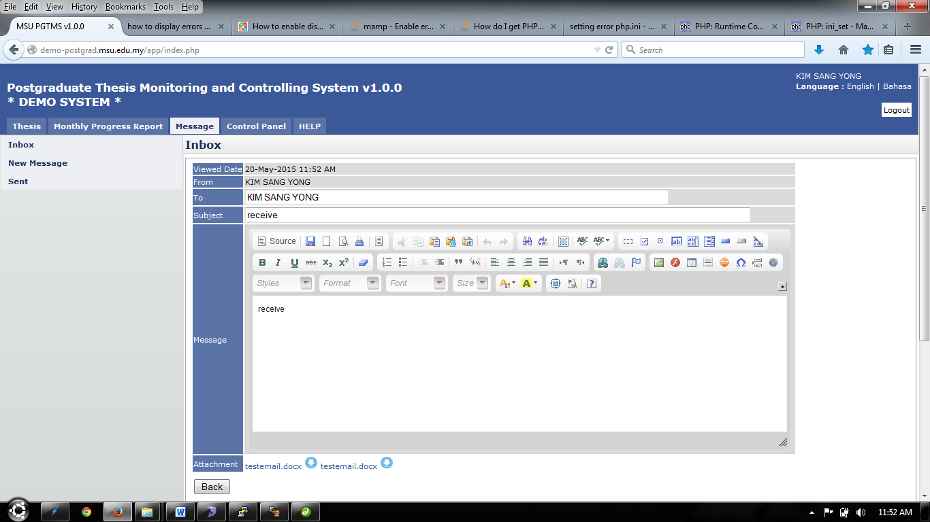

Figure 65: Read Message

**Steps:-**

1. This page only displays the message that has been open by the user.
2. To view or download the attachment that been sent, click  or link shown on figure 62.
3. To go back to the previous page, click **Back** button.

## New Message

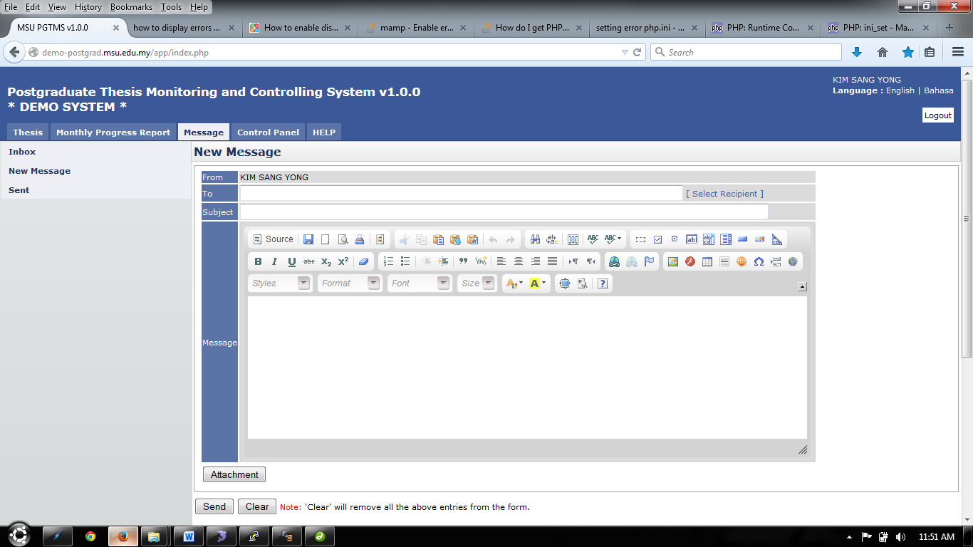

Figure 66: New Message

**Steps:-**

1. Click on the **Message** tab on the **Top** panel
2. Click on the **New Message** menu on the **Left** panel
3. To select recipient, click. Next step refer Select Recipient
4. Insert or enter necessary detail in **Subject** and **Message**.
5. To upload or include attachment for message, click **Attachment** button. Next step refer Upload Attachment.
6. To erase or clear the entire entries, click **Clear** button.
7. To send the message, click **Send** button.

### Select Recipient

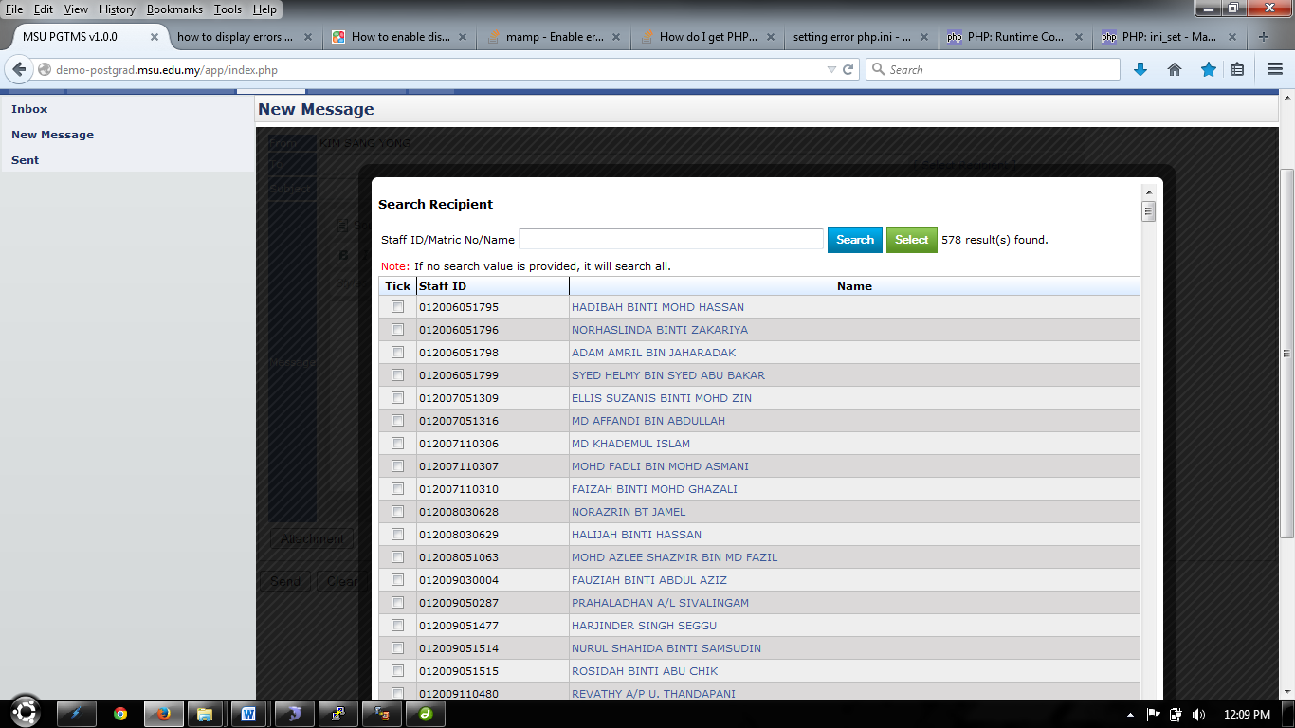

Single recipient can be select by click on the name displayed.

Figure 67: Select Recipient

**Steps:-**

1. Enter or insert **Name** or **Staff ID** or **Matric No** and click **Search** button.
2. The system will display the result based on searching criteria.
3. To select one recipient only, click on the **Name** displayed.
4. To select multiple or single recipient, tick on the checkbox on the left.
5. Then click **Select** button to proceed.
6. To go back to the previous page, click on the **Black** field surrounding the page. Refer Figure 68



Click the **Black** field, to go back to previous page

Figure 68: Select Recipient- Next Section

### Upload Attachment

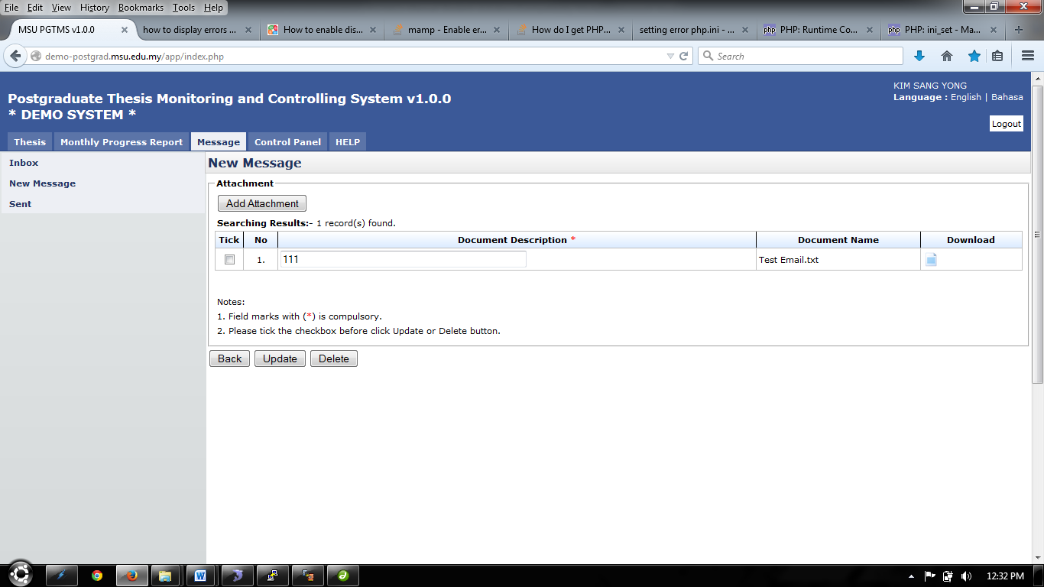

Figure 69: Upload Attachment

**Steps:-**

1. To add attachment, click **Add Attachment** button. (Refer Figure 69)

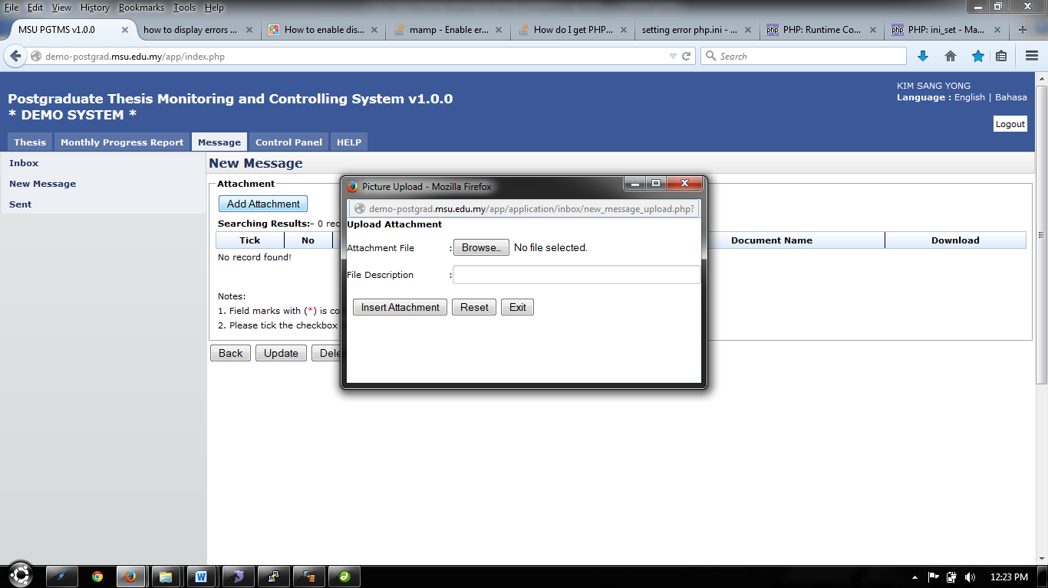

Figure 70: Upload Attachment- Next Section

1. To choose attachment, click Browse.. button and choose the file to upload.
2. To file description can be insert in the field provided.
3. Click Insert Attachment button to proceed.
4. To clear all the entries, click Reset button.
5. To exit or close the popup, click Exit button.
6. To upload more file, repeat step 1 until step 4.
7. To edit file description, change necessary detail, then tick the checkbox and click Update button to proceed.
8. To delete file, tick the checkbox and click Delete button.
9. To download or open the file that has been uploaded, click 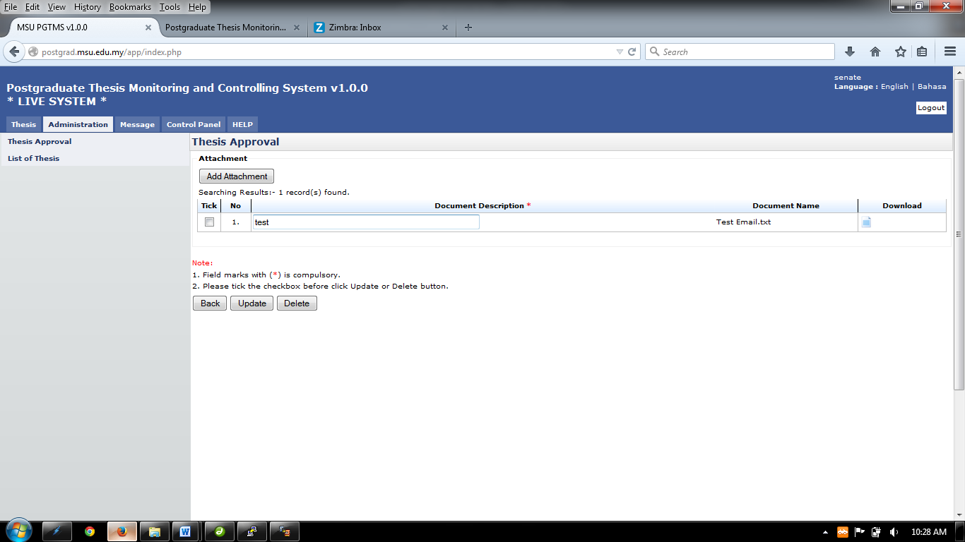on the Download column.
10. To go back to previous page, click Back button

## Sent

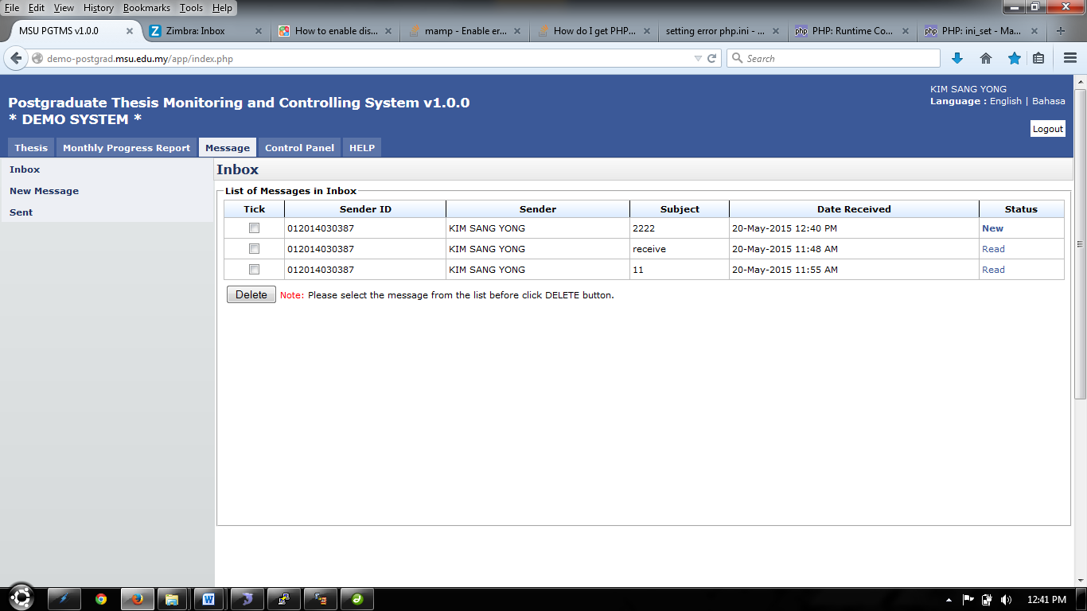

Figure 71: Sent

**Steps:-**

1. After message has been sent, it will be display in **Sent** Left panel
2. Click **Message** tab on **Top** panel
3. Click on the **Sent** on the **Left** panel
4. The system will show the list of message that has been sent by user.
5. The status of the message also had been show on the far right side which is in **Status** column. If the message has been read by recipient, it will display **Read.** If not, it will display **New.**
6. Click the link on the **Status** column to read the message. (Refer Read Message)
7. To delete message, tick the checkbox and click **Delete** button.

### Read Message



Figure 72: Read Message

**Steps:-**

1. This page only displays the message that has been open by the user.
2. To view or download the attachment that been sent, click  or link shown on figure 69.
3. To go back to the previous page, click **Back** button.

# Help

## Online help - Student

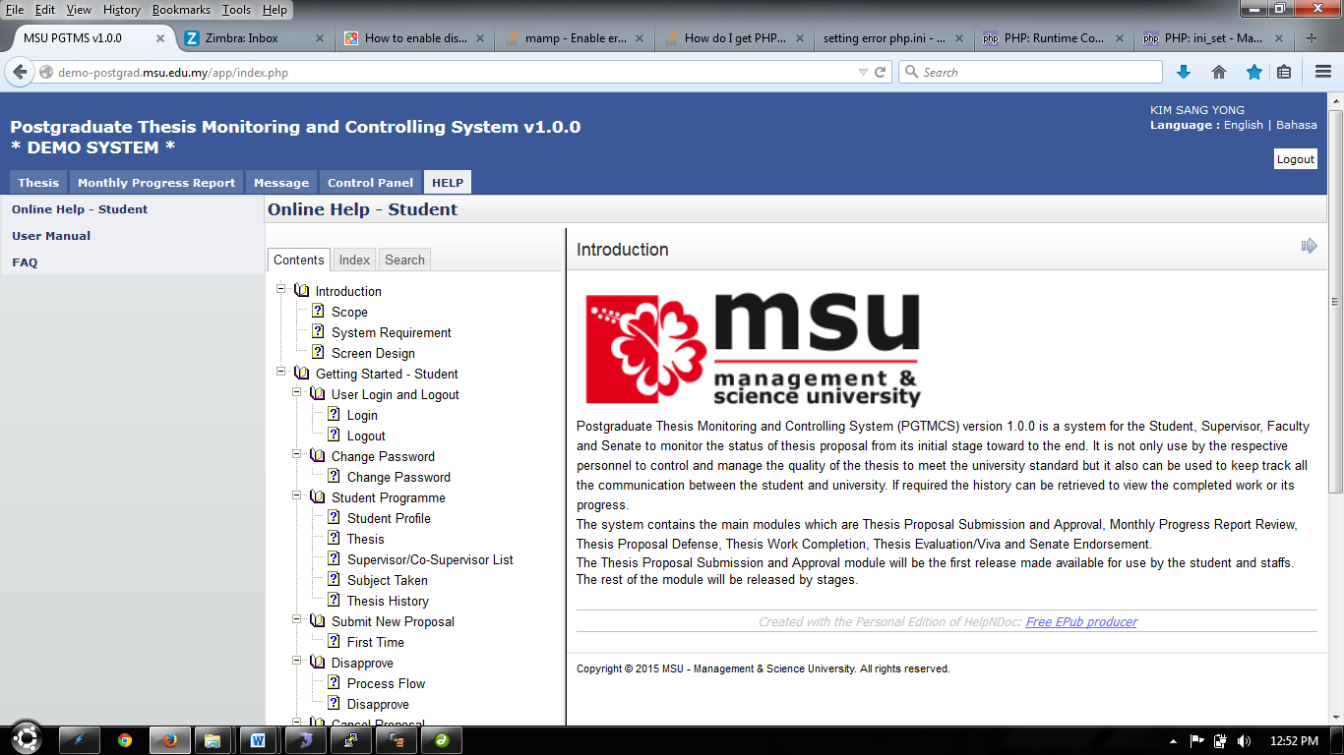

Figure 73: Online Help

**Steps:-**

1. Click on the **Help** tab on the **Top** panel
2. Click on the **Online Help - Student** menu on the **Left** panel
3. System will display an online help which is functioning as guide.

## User Manual

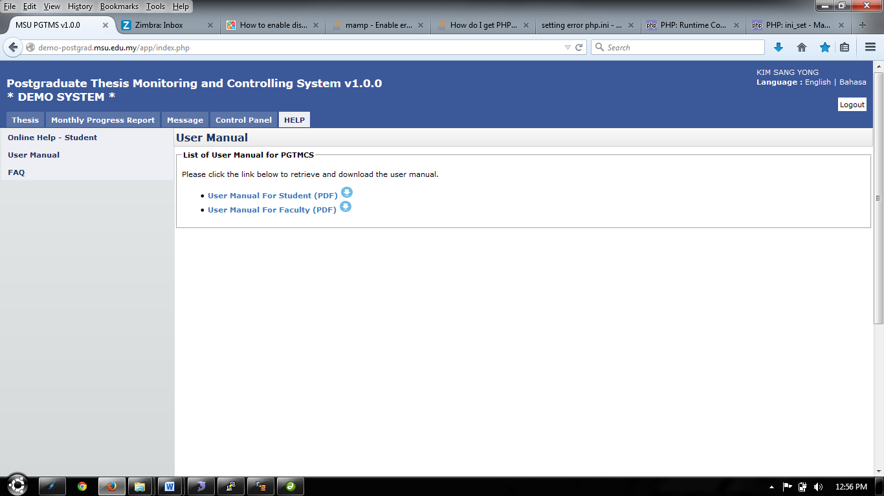

Figure 74: User Manual

**Steps:-**

1. Click on the **Help** tab on the **Top** panel
2. Click on the **User Manual** menu on the **Left** panel
3. System will display link to download user manual.

## FAQ

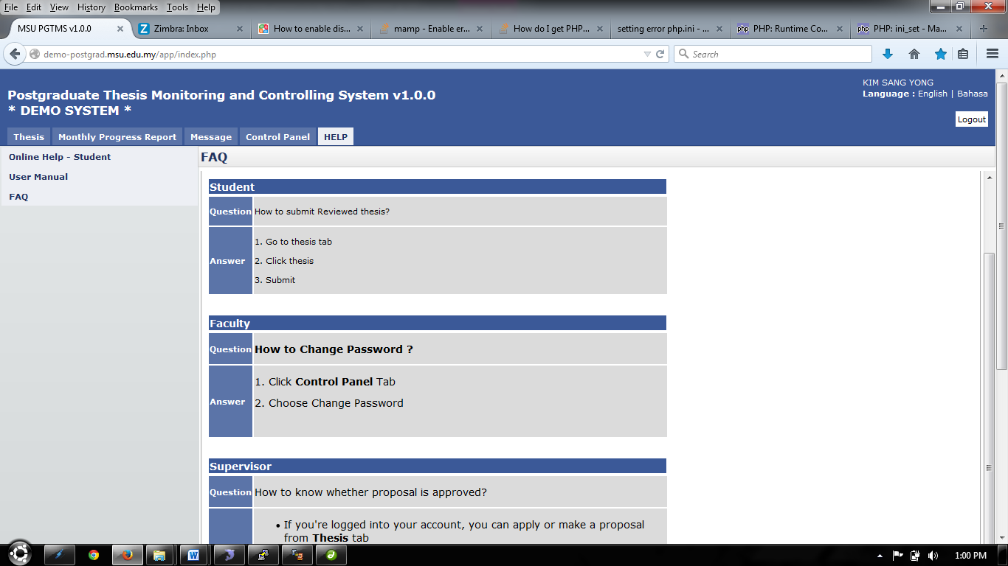

Figure 75: FAQ

**Steps:-**

1. Click on the **Help** tab on the **Top** panel
2. Click on the **FAQ** menu on the **Left** panel
3. System will display Frequent Ask Question.

APPENDIX

# Email Template - Student to Faculty

## Thesis Proposal – Submission

To: [gsm@msu.edu.my](mailto:gsm@msu.edu.my) <[gsm@msu.edu.my](mailto:gsm@msu.edu.my)>

From: [kimsangyong@msu.edu.my](mailto:kimsangyong@msu.edu.my) <[kimsangyong@msu.edu.my](mailto:kimsangyong@msu.edu.my)>

Cc: [kimsangyong@msu.edu.my](mailto:kimsangyong@msu.edu.my) <[kimsangyong@msu.edu.my](mailto:kimsangyong@msu.edu.my)>

Subject: Thesis Proposal by KIM SANG YONG – Submitted



|  |  |
| --- | --- |
| Dear Sir, |  |
| I am pleased to submit the thesis proposal as follows :-. |  |
|  |  |

|  |  |
| --- | --- |
| **Student Name** | KIM SANG YONG |
| **Matric No** | 012014030387 |
| **Thesis ID** | T20150513001 |
| **Submit Date** | 13-05-2015 |
| **Thesis/Project Title** | 11111111 - submit_proposal.php |
| **Proposal Type** | Research |
| **Student Email** | samkim302@yahoo.com |

Thank you,

Best Regards,

KIM SANG YONG

Management & Science University

Please do not reply directly to this email. © MSU 2015All rights reserved.  
  
Management & Science University.  
University Drive, Off Persiaran Olahraga,  
Section 14, 40100 Shah Alam,  
Selangor Darul Ehsan.

# Email Template - Student to Supervisor

## Monthly Progress Report - Submission

To: [mdgapar@msu.edu.my](mailto:mdgapar@msu.edu.my) <[mdgapar@msu.edu.my](mailto:mdgapar@msu.edu.my)>

From: [kimsangyong@msu.edu.my](mailto:kimsangyong@msu.edu.my) <[kimsangyong@msu.edu.my](mailto:kimsangyong@msu.edu.my)>

Subject: Monthly Progress Report Submitted by KIM SANG YONG



|  |  |
| --- | --- |
| Dear Sir, |  |
|  |  |
| I am pleased to submit the monthly progress report as follows :-. |  |
|  |  |

|  |  |
| --- | --- |
| **Student Name** | ABDUL HAFIZ BIN IBRAHIM |
| **Matric No** | 012013110572 |
| **Thesis ID** | T20150602001 |
| **Thesis Title** | System testing v2 |
| **Month** | January 2015 |
| **Reference No** | R20150602001 |
| **Submission Date** | 02-Jun-2015 10:32 AM |

Thank you,

Best Regards,

ABDUL HAFIZ BIN IBRAHIM

Please do not reply directly to this email. © MSU 2015All rights reserved.  
  
Management & Science University.  
University Drive, Off Persiaran Olahraga,  
Section 14, 40100 Shah Alam,  
Selangor Darul Ehsan.

This page is intentionally left blank.